School: AL-Majd Modern Basic School
Second grade Mid-term worksheet Date: 25\10\2015 Teacher : Rana Rihan Name:
1) Complete the dialogue

Hello what’s your name?
My name's ……………
How old are you? I'm ……………

2) Circle and write
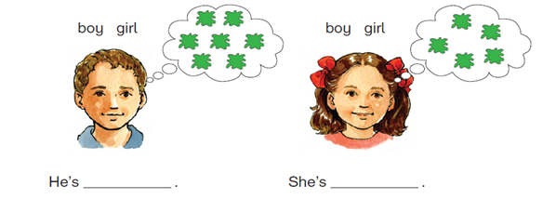
3) Write

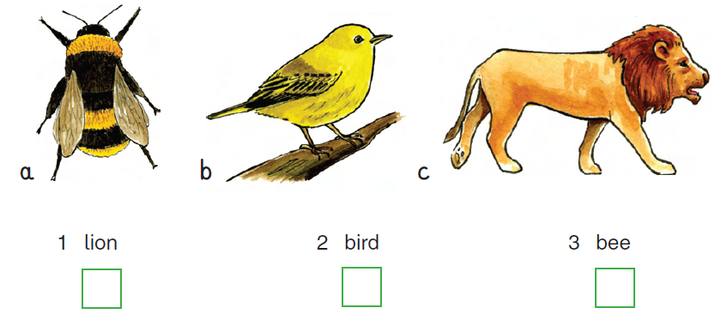

4) Read and match
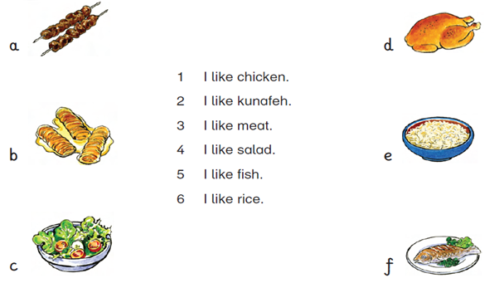

5) Writee

She | He | Likes | Oranges | Apples | Ice cream | Kunafeh
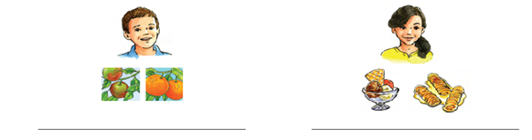
6) Circle

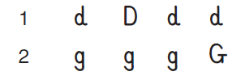
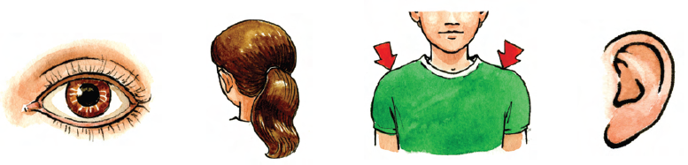
7) match
8) Read and circle
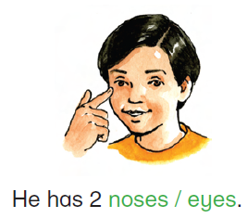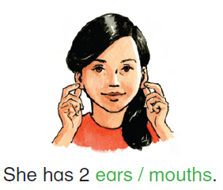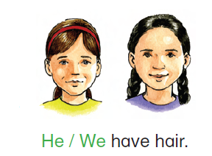
9) Complete

Good Luck

