2nd Grade تقييم أداء نصف الفصل الأول الصف الثاني لغة انجليزية2014
Name : ……………………….. units:1,2,3&4 Mark: ………………………..


- Listen and circle (5m) :-استمع وحوط

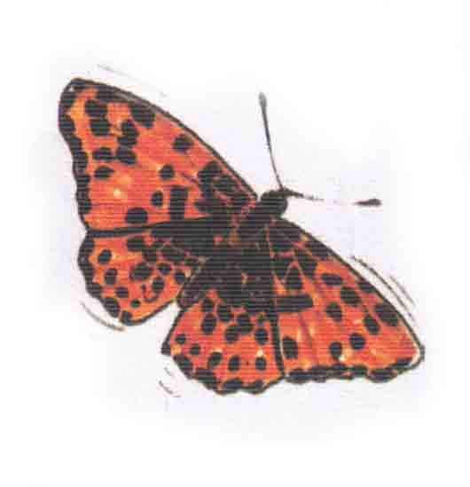
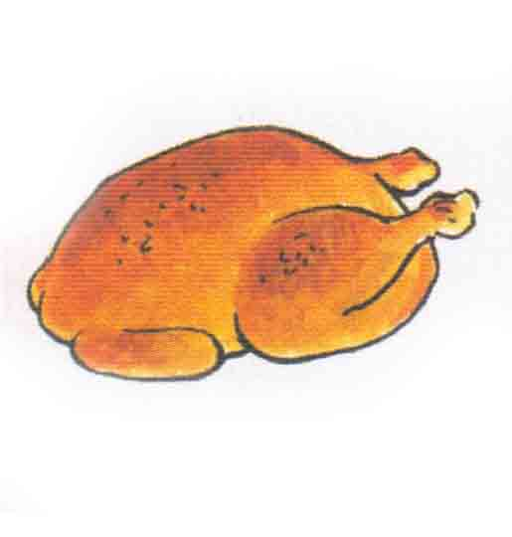
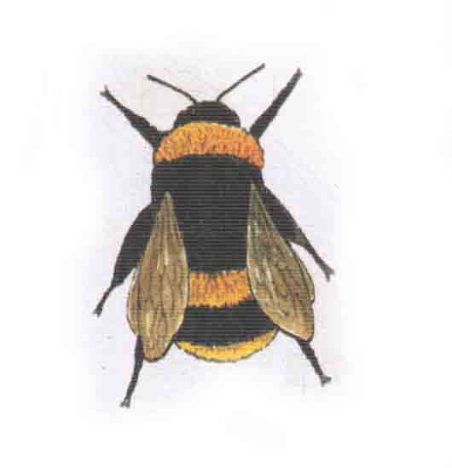
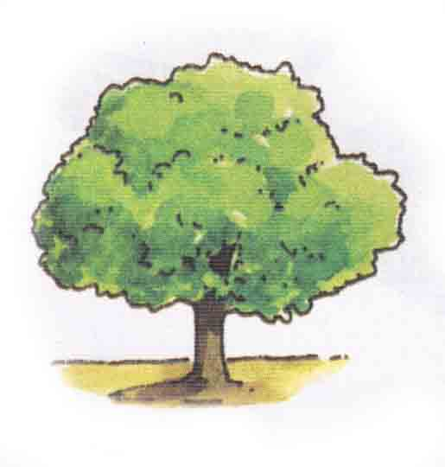

- Match ( 5m ):- صل
1*Good morning |  | My name's Tala.
2*What's your name? |  | Good morning.
3*How old is Adam ? |  | Goodbye, Amir.
4*What does he like? |  | He,s 7.
5*Goodbye ,Tala. |  | He likes melon.

- Choose ( 4m ):-اختر
1*I (like-likes) chocolate.
2*(A bee-A lion) has 6 legs.
3*She (like-likes) melon.
4* He (has-have) 2 eyes.

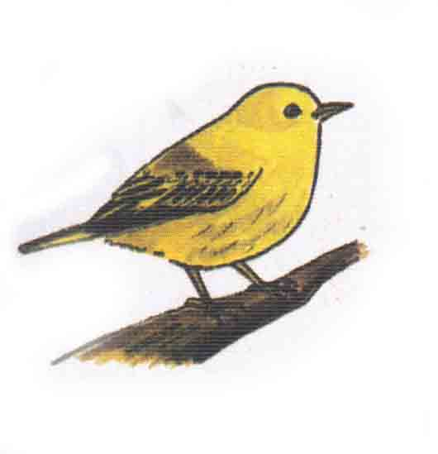
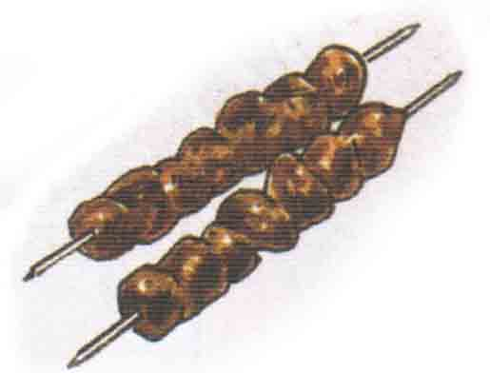

- Choose and write (5m ):- {m-e-b-f-t } واكتب اختر

…lower ….ird ….ree ….eat ….ar

- Copy (1m):- A bird has 2 legs. اكتب بخط جميل

