Omar Ben Abdul-Aziz School
Midterm exam for 3rd grade
الاسم ..................................................... الصف الثالث .........

استمع ورقم 1- Listen and number:-5m
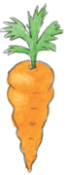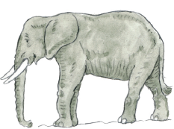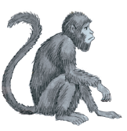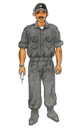



صل 2-Match :-4m
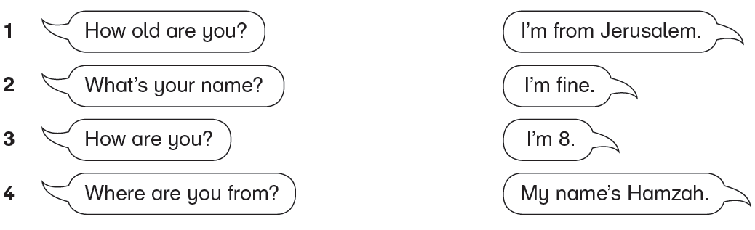
رتب الجملة 3-Write :-1m
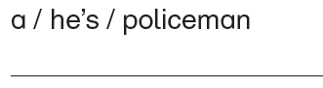
أقرا ثم اكتب Read and write:- 5 m 4-
( fish  / chicken  / carrots / ice cream / fig )

I like ………………… and ……………… *

* I don’t like …………….. , …………….. and ……………..
اقرا ثم اختر 5- read and choose :6m

Dina is a girl . She is from Ramallah . she is eight . She has green eyes and yellow hair .
- Dina is a ……………. ( boy - girl )
- She is from ……………… ( Ramallah - Nablus )
- Dina is ………………. ( 9 - 8 )

انظر ثم ضع دائرة 5-Look and circle :-5m

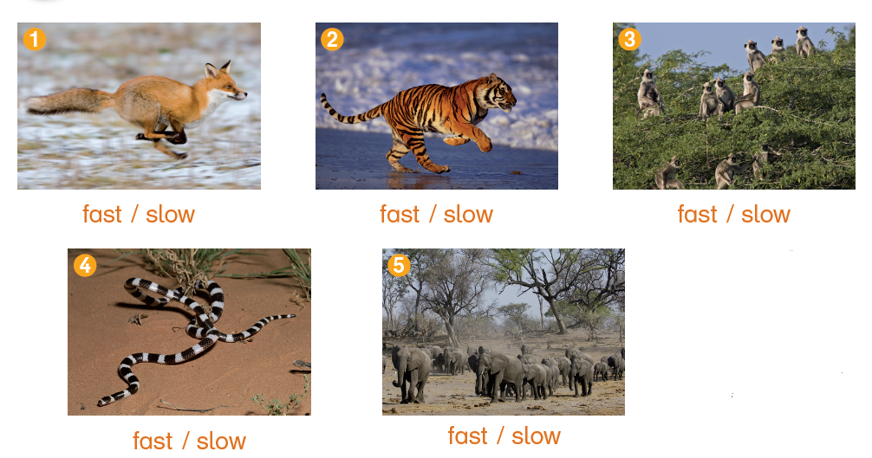

اقرأ ثم حوط3-Read and circle :-4m
I ( like – don’t like ) fish .  -1

2 – I ( like – don’t like ) bananas .

@@@@

T. NOUR ))

