Second Mid Term Exam First Class

20

Name: ____________________________Class: ____________ Mark:

1-Listen and circle :- ضع دائرة حول الكلمة التي تسمعها
1 | 2 | 3
car | bike | water
kite | baby | white

2- Complete the dialogue: أكمل الحوار
Hello - There – Amir - ball

Amir | Sami
…………………………… Sami.  …………………………! | - Hello,…………………………  - Where's my …………………?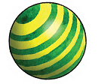
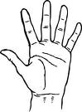
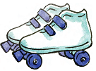

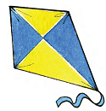
3. Mach :

hand skates Kite doll
Five - bikes - Three

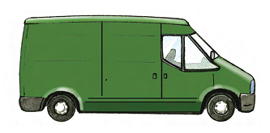
4- How many:
1- _________ vans.
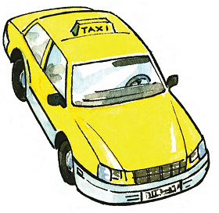

2- _________ cars.

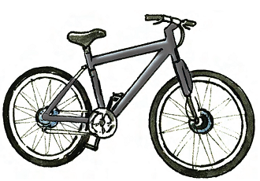
3- seven _________.
5-
Yes / No

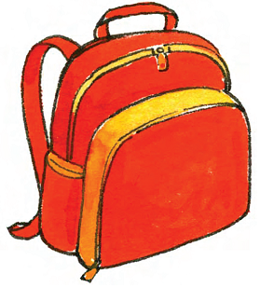
1- Is this a bag? ______.

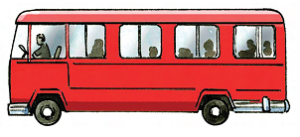
2- Is this a car ? ______.

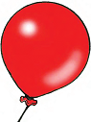
3- Is this a balloon? ______.

6- Handwriting

