Grade “6” Daily English Exam Name: -------------------
Score:” 30 mark “ Unit “6” Date:23rd Nov. 2014
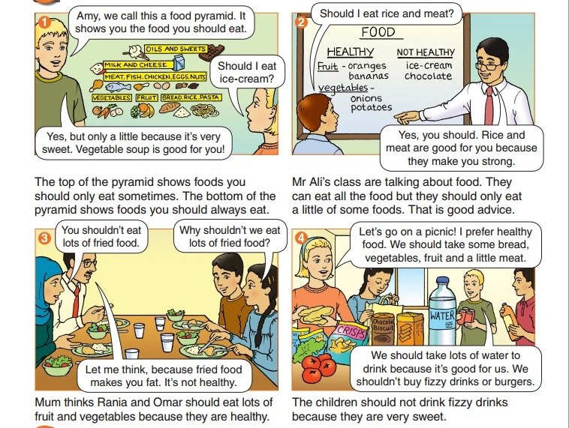Q1-Answer the following questions: (4points)
1- What are Ben and Amy looking at ?
---------------------------------------------------------------------------------.
2-Why are fizzy drinks are not healthy?
-----------------------------------------------------------------------------------
3- What does the top of the food pyramid show?
------------------------------------------------------------------------------------.
4- Why should we drink water?
-----------------------------------------------------------------------------------
Q2-complete the following : (2points)
1 -We ------------------------- not eat lots of fried food.
2- Ice-cream is very sweet. You should only eat a little ice-cream. It’s at the------------- of the food pyramid.

Q3-Write (True) or (False) : (2points)
a. We should eat fried food a lot. T F
b. Mr. Ali is talking about drinks . T F
Language
Q1-Choose the correct answer: (5points)
1- Omar and Bilal ----------------------------- friends. ( are / is )
2- They ----------------------- to school every day. ( go / went )
3- Ali ------------------------ a problem . (have / has )
4- She ----------------------------- Arabic always. ( don’t study / doesn’t study)
5- I ----------------------- a student. ( am / are )

Q2- Correct the verbs between the brackets: (5points)
1 Amy should eat vegetable soup because it-------------------- (be) good for her.
2 Rania shouldn’t eat lots of fried food because it -------------------- (make) her fat.
3 The children shouldn’t drink fizzy drinks because they----------------- (be) very sweet.
4 Omar always ---------------------------------- ( study ) hard .
5- The sun ----------------------- ( rise ) every day.

Vocabulary
*Complete with the suitable words: (5points)
( prefers / pyramid / health / fried / soup )
1 My mother makes --------------------------------- it is delicious .
2 Healthy food is good for you ------------------ it makes you strong.
3 Amy ------------- healthy food. She wants to take bread and a little meat to the picnic.
4 You shouldn’t eat lots of ----------------------------- food. It is unhealthy.
5 You should eat a lot of food at the bottom of the food --------------------

Writing
****Give advice USE “ should ” “ shouldn’t : (5points)
1- eat / healthy -------------------------------------------------------------------.
2- drive fast --------------------------------------------------------------------.
GOOD LUCK Teacher: Thaira Abed Al-Rahman

