State of Palestine Grade : Six
Ministry of Education & Higher Education Number of Q : 4
Directorate of Education/ Jenin Date : / 11 / 2015
Al Hashimiya Secondary Girls School Name:……………..
Time :45.m Third Exam- First Semester Total Mark : 50 p
===========================================================================================
Question Number One: Read the following text then answer the questions that follow: (20 Points)
The top of the food pyramid shows you the food you should eat sometimes, this food like fried food, fizzy drinks and burgers, this food is not healthy. The bottom of the food pyramid shows you the food you should eat always, this food like vegetable soup, meat, rice and water. That's a good advice. So we shouldn't buy fizzy drinks and ice-cream because they're very sweet.
A) Answer the questions:
1- What food you can find at the top of the food pyramid?
………………………………………………………………………………………….
2- What is the food that we should eat always ?
…………………………………………………………………………………………..
3- Why shouldn't we eat lots of ice-cream?
…………………………………………………………………………………………..
B ) Give examples for :
a- food that we should eat sometimes : 1: ………………..… 2: …………………..
b- food that we should eat always : 1:…………………...…. 2: …………………….
C)Get from the passage:
1- two present verbs : 1: …………………… 2: ……………………..
2- the opposite of : a- top…………………… b- bad…………………
D)Say whether these sentences ara true or false :
1- Fizzy drinks and burgers are not healthy . ( T / F )
2- The bottom of the food pyramid shows you the food you should eat always . ( T / F )
=======================================================================================
Question Number Two :
A-Fill in the spaces with words from the box: ( 10 pts )
Vegetables – fried - healthy – good advice - soup – sweet
1-I should eat lots of…………………….. food.
2- Rania and Omar should eat lots of fruit and ……………………..
3- Fizzy drinks are very ………………………..
3- You shouldn't eat lots of ……………..food.
4- Vegetable …………….. is good for you.
5- To eat healthy food is a …………………
B- Choose the correct answer :
1- Ali ( show – shows – showed ) me a food pyramid yesterday .
2- Children ( should – shouldn’t ) drink fizzy drink .
3- From now , We shouldn’t ( buy – buying – bought ) burgers .
4- Amy ( wants – want – wanted ) to eat ice-cream .
Question Number Three : Writing : ( 10 pts )
Think and write the correct answers:
What should / shouldn't they do ?
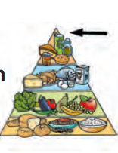
eat / healthy / food
…………………………………..
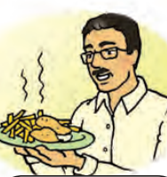
eat / lots of / fried food
…………………………………..
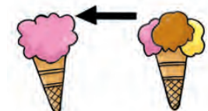
only eat / a little ice-cream
…………………………………..
=============================================================================
Question Number Four : Listening and Speaking : ( 10 pts )
1-Listen and Circle the correct words :
a- We ( Should – should not ) eat lots of fried food .
b- You should eat ( a lot of – a little ) cake .
c- ( Burgers – vegetable soup ) is a healthy food .
d- We prefer ( water – fizzy drinks ) because it is healthy .
e- My dad said , You should only eat fried food sometimes ? That’s good ( answer – advice )
=============================================================================
Strong
Goodbye
healthy
Hamzah
Good morning
are

Thanks
are
Bilal
2-Complete the dialogue :

Bilal : Good morning , ……………… .
Hamzah : ……………………….. , Bilal .
Bilal : How …………………. You ?
Hamzah : I'm fine , ……………………….. .
Bilal : What is ………………………. Food ?
Hamzah : Its make you …………………… .
Bilal : …………………………. , Hamzah .
Hamzah : Goodbye , …………………….. .
Good Luck

