State of Palestine Grade : Two
Ministry of Education & Higher Education Work sheet U. 7
Directorate of Education/ Jenin Date : /12/2014
Al Hashimiya Secondary Girls School Time : 10.m
==================================================================================================== Aims :To practice listening .To write the correct word . To choose the correct preposition .To practice handwriting the letters J j / U u / U u .
*****************************************************************************************************
1- Let’s listen and write :
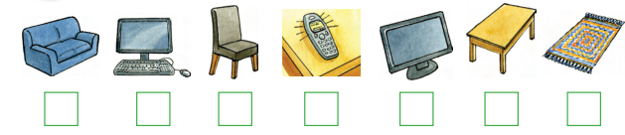
2- Look and write :
rug - on - telephone - under - TV - in

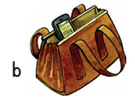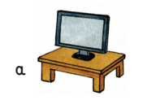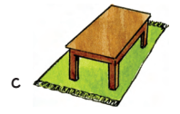
The ……………..is ……the bag . The ………. is ………….. the table . The …………is ……… the table.
3- Circle :
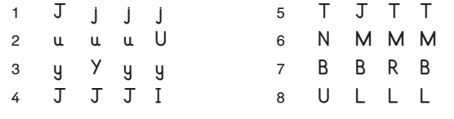
Good luck
Teacher’s notes : ………………………… Parent’s notes : ………………………….

