State of Palestine Grade : Three
Ministry of Education & Higher Education Worksheet U. 8 Directorate of Education/ Jenin Date /12/2014 Al Hashimiya Secondary Girls School Time : 10.m
Name : …………………….
========================================================================================
Aims : To match pictures with sentences .To write the correct word . To circle the correct preposition.To practice handwriting .
*******************************************************************************************
1- Match :
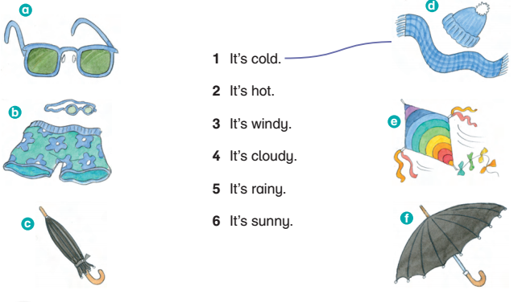

2- Write :

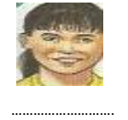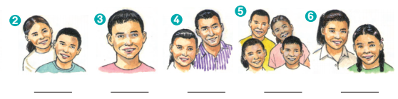
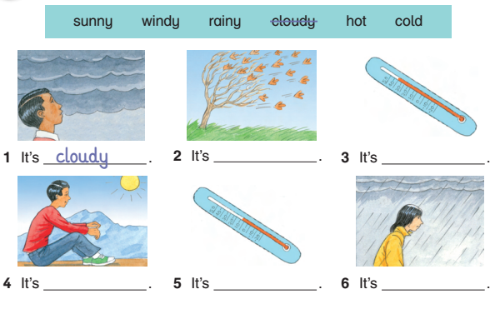

3- Circle the correct word :
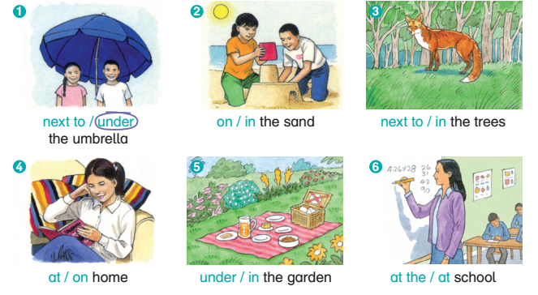

4- Copy and write :

Good luck
Teacher’s notes : ………………………. Paren’s notes : ………………………….

