State of Palestine Grade : Three
Ministry of Education & Higher Education Worksheet U. 1 Directorate of Education/ Jenin Date : 19/10/2014 Al Hashimiya Secondary Girls School Time : 10.m
Name : …………………….
===========================================================================================
Aims : ( 1 ) To listen and write the names . ( 2 ) To circle the correct answer . ( 3 ) To complete the sentences .
A: Listen and write :
Hamza - Reem - Nour

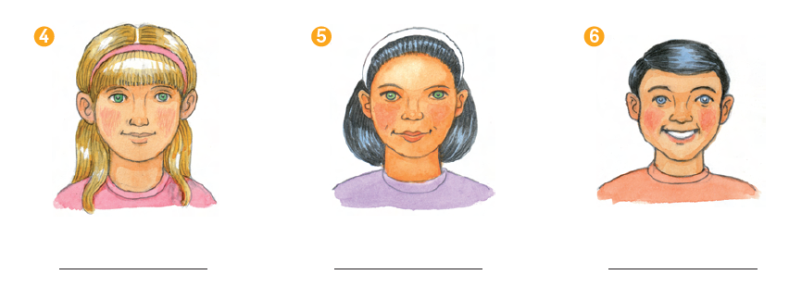
B: Circle the correct word :
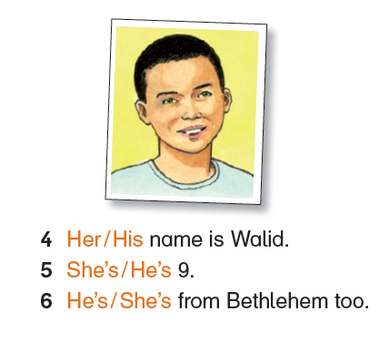

C: complete the sentences :

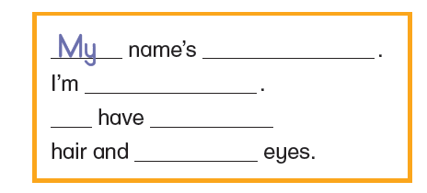
D : Write

__________________________________________________________________________________________________
__________________________________________________________________________________________________
__________________________________________________________________________________________________
__________________________________________________________________________________________________

__________________________________________________________________________________________________
__________________________________________________________________________________________________
__________________________________________________________________________________________________
__________________________________________________________________________________________________

Good luck

