|  |  |  |
| --- | --- | --- |
| **Name :** |  | **State of Palestine** |
| **Class: 3rd ( A )** | **Ministry of Education & Higher Education** |
| **Date : 17 / 11 / 2016** | **Directorate of Education / Southern Hebron** |
|  | **Al-Farouq Boys Basic School** |

***1- Listen and circle the word you hear :*** ( 4 points )

1-potatoes tomatoes carrots melons

2- doctor nurse farmer driver

3- father mother brother uncle

4- four five fourteen fifteen

**2. Match: ( 6 points)**

tomato carrot tiger teacher farmer fox

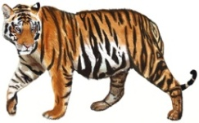   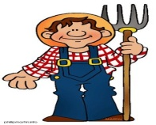  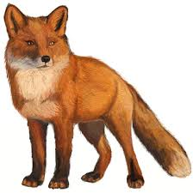

**3. Complete the sentences ( 4 points)**

**black big fast no**

1. The snake has ______ legs .
2. My favorite colour is __________.
3. The elephant is very __________.
4. The monkey runs __________.
5. **Read and circle ( 2 points)**
6. I **like / don’t like**  oranges. ☺

b. I **like / don’t like**  snakes. ☹

5) Circle :- **( 2 points)**

1- I am small . I have two legs . I am fast . What am I ?......................

( giraffe – monkey – snake )

2- I am very big . I have four legs . I am slow . I am grey . What am I ?......................

( tiger – snake – elephant

**6-Count and write the numbers : ( 4 points )**

1.  **___________ bananas.**
2. ** _________ ice-creams**
3. 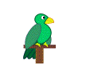 **___________ parrots.**
4. ** ___________grapes**

**7 – Write (3 points)**

I can see a fox . It has four legs .

_____________________________________________________________________________________________________

_____________________________________________________________________________________________________

_____________________________________________________________________________________________________

_____________________________________________________________________________________________________

Teacher :

Talal Meawei