|  |  |  |
| --- | --- | --- |
| دولة فلسطين  وزارة التربية والتعليم العالي  مديرية التربية والتعليم قلقيلية  ذكور كفر قدوم الاساسية | **pnalogo(2)(11)(1).bmp** | State of Palestine  Ministry of Education and Higher Education  Director of Education/Qalqilya  Kuffer Qadoom basic boy's school |

Grade : 2nd Worksheet ( unit 10 ) Date : \ \ 2016

**Teacher : Tha'er Z. Taha Name:______________________**

**1- Look and write. (Singing – Playing football – drawing – Swimming)**

** **

**___________________ __________________________**

** **

**_____________________ ___________________________**

**2- Choose. (She – He – We)**

**① ______________ like playing with friends.** 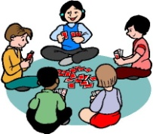

**②______________ likes dancing. **

**③ _____________ likes reading. **