

**Name:**

**Class:**[**4th Grade**](https://www.wepal.net/library/?app=content.list&level=4&semester=1&subject=5&type=2&submit=submit)

**Time:**

**Date:**

**U--4**

**Palestine State**

**Ministry of Education**

**Directorate of Tulkarem**

**Nazlet Issa Basic Boys' School**

**----------------------------------------------------------------------------------------------------------------------------**

**Read the passage and answer:**

**" Let's go shopping. We need three kilos of potatoes, two cartons of milk and two bags of pasta. Fiona needs three packets of biscuits."**

**:Complete :-**

**1. Let's go …………………………( shopping – cooking ).**

**2. We need three kilos of ( biscuits – potatoes ). Put ( √ ) or ( × )**

**1. We need three cartons of milk. ( )**

**2. Fiona needs three packets of biscuits. ( )** **Answer**

**How many bags of pasta do we need ? ……………………………………………………**

**\*\*\*\*\*\*\*\*\*\*\*\*\*\*\*\*\*\*\*\*\*\*\*\*\*\*\*\*\*\*\*\*\*\*\*\*\*\*\*\*\*\*\*\*\*\*\*\*\*\*\*\*\*\*\***

[**Complete the dialogue:**](https://www.wepal.net/library/?app=content.list&level=4&semester=1&subject=5&type=2&submit=submit)

**( dinars – you- Good morning -Ahmad – Fine-pasta – would- much )**

**Good morning,……………………….. 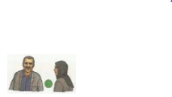 ……………………………, Hala**

**How are you ? …………………………….., thanks**

**What ………………. you like? I'd like bag of …………………….**

**Anything else? No, thanks. How …….……..is it?**

**Two ……………………………. Here ………………………….. are**

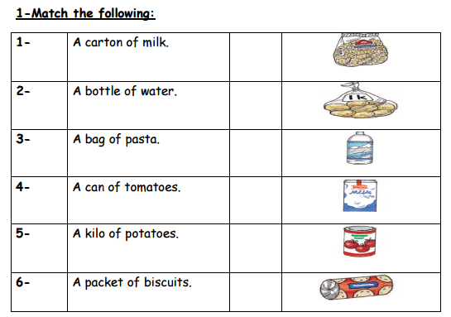

**-Rearrange:**

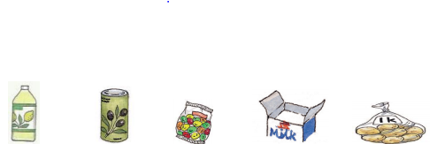

**ttoleb anc abg tcaron loki**

**……………….. …………… …………… …..……………. ……………**

**----------------------------------------------------------------------------------------------------**

[-**Choose:**](https://www.wepal.net/library/?app=content.list&level=4&semester=1&subject=5&type=2&submit=submit)

**1. How …………is it ? Five dinars. ( many – much – old)**

**2. It's a can of …………… ( potato – milk – fish)**

**3. I'd ……………..a bag of rice, please. ( like – bike – thank)**

**4. There are ………………..packets of biscuits. ( five – ten –seven ). **