[**اختبار نهاية الفصل الدراسي الثاني للعام 2015 / 2016 م**](https://www.wepal.net/library/?app=content.list&level=5&semester=2&subject=5&type=2)

**40**

**دولـــــــــــــــــــــــــــــــــــــــــــــــــة فلســــــــــــــــــــــــــــــــــــــــــــــــــــــــــــــــــــــطين**

**وزارة الــتــــــــــــربـــــيــــــــــة والـــتــعــــلــيـم الـــعــــالـــــــــــــــــــــــــــــــــي اسم الطالب: .......................**

**مـــديــــريــــــة الـــتـربـــيـــة والــتـعــلـيم-شــــرق خــان يـــونـــس الصف:** [**الخامس مسائي**](https://www.wepal.net/library/?app=content.list&level=5&semester=2&subject=5&type=2)

[**المادة: اللغة الانجليزية**](https://www.wepal.net/library/?app=content.list&level=5&semester=2&subject=5&type=2)

**1) Listening (6 Marks)**

***1) Listen and number the pictures: -***

**5 points**

[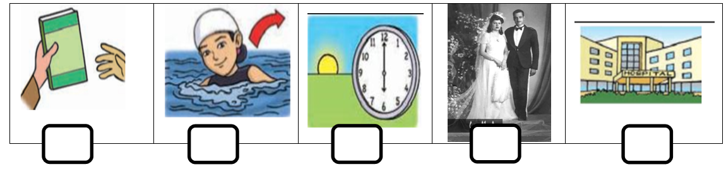](https://www.wepal.net/library/?app=content.list&level=5&semester=2&subject=5&type=2)

**1 point *2)*** [***Listen and choose:***](https://www.wepal.net/library/?app=content.list&level=5&semester=2&subject=5&type=2)***-***

1) Ben's family are going to have a………………… (**picnic –tour – holiday**).

(**Jerusalem –Bethlehem - Jericho**). 2) The Aqsa Mosque is in………………………

**6 Marks**

**2) Speaking**

**4 points**

***3) complete the dialogue:-***

**Omar** : When did you …………………. Your leg, Ben?

**last**

**Better**

**Football**

**taking**

**hobby**

**break**

**leg**

**did**

**Ben** : I broke my leg ………………….. summer.

**Omar** : How ………………….. you do that ?

**Ben** :I broke my leg in a …………………… game .

**Omar** : How's your ……………………. now ?

**Ben** : ……………………... thanks .

**Omar** : What' your …………………. ?

**Ben** : My hobby is …………………… photos .

***A) What would you say in the following situation:-* 2 points**

1- When you start a story?

a) In the end b) once upon a time c) I'm sorry

2- Can I try your mobile phone, please?

a) Sure, here you are. b) Yes, come in c) Turn it on.

تابع خامس مسائي – 2 -

**3) Reading (7 Marks)**

4

[***Read the passage then answer the questions:-***](https://www.wepal.net/library/?app=content.list&level=5&semester=2&subject=5&type=2)

Ben tells Omar about his blog. The blog is on the internet. Ben writes his ideas and puts photos in the blog .Omar reads about Ben in his blog. Last summer Ben broke his leg at the football game. Dad took him to the hospital.

***1) True or false:-*  *1 point***

a- Ben broke his leg last weekend. ( )

b-You can see a blog on the internet. ( )

***2) Complete:- 2 points***

a) Ben writes his ………………… and puts ……………………… on his blog.

b) Ben broke his ………………….. and his dad took him to the …………………….. .

***3) Get from the passage:- 4 points***

a) The opposite of: first X …………………... b) gave ×…………………..

c) The past of: (break) …………………… (take) ………………………. .

d) What did Ben write in the blog? ……………………………………………………………………. .

e) Where did his dad take Ben? ……………………………………………………………………………… .

**4) Vocabulary** **(8 Marks)**

**5 points**

***1- Complete with a word from the box:***

**restaurant - travel - princess - hide - nothing princess**

1- Let's play ……………………… and find.

2-Amy's aunt looks like a …………………….. .

3- The greedy farmer got ………………………. .

4- The …………………………. was a nice place.

5- The family are going to …………………… by car.

**3 points**

***2- Classify the following:-***

laptop news doctor park sports robot

driver zoo scientist mobile phone hospital cartoons

**Jobs Machines TV programmes place**s

تابع خامس مسائي – 3 -

**5) Language**

**5 marks poMarks**

***Choose the correct answer:-***

**5 points**

1) The wolf laughed ………………….. (on - at – in ) the farmer .

2) The car couldn't…………………….. (drive – got – move ) .

3) What……………….. (does – doing - did ) Omar do yesterday?

4) The children ………………….. ( are – was – were ) at the park last night .

5) We are ………………… ( use – used - using) a computer now .

**6) Writing**

**8 marks Marks**

***a) Do as shown in the brackets:-***

**4 points**

1- amy told rania about the wedding ( **Punctuate** )

………………………………………………………………………………………. .

2-chocolate – some - like – you – Would? (**Re**- **arrange**)

………………………………………………………………………………………….. .

3- Did you watch cartoons yesterday? (**answer**)

………………………………………………………………………………………….. .

4- Here are any grapes . ………………….. (**correct**)

***b) Think of the clues:-***

**3 points**

1) A word which means two. What is it? ………………… .

2) You can see people and things in me. What am I? …………………. .

3) I taste like sugar. I'm a plant. What am I? …………………… .

**1 points**

***d) Hand writing:-***

**Jerusalem is a beautiful city.**

انتهت الأسئلة

[**Listening Textاستماع الخامس مسائي**](https://www.wepal.net/library/?app=content.list&level=5&semester=2&subject=5&type=2)

[***1) Listen and number the picture:-***](https://www.wepal.net/library/?app=content.list&level=5&semester=2&subject=5&type=2)

1- Rania's aunt got married last summer.

2- Can I borrow your book, please?

3-Omar got out of the cold water.

4- Ben's dad took him to the hospital. .

5- We go to work at six o'clock.

***2) Listen and complete-***

Ben's family are going to have a holiday. They are going on a tour of Palestine next October. They will visit Jerusalem to see Al- Aqsa Mosque and The Dome of Rock.

**Listening Textاستماع الخامس مسائي**

***1) Listen and number the picture:-***

1- Rania's aunt got married last summer.

2- Can I borrow your book, please?

3-Omar got out of the cold water.

4- Ben's dad took him to the hospital. .

5- We go to work at six o'clock.

***2)*** [***Listen and complete***](https://www.wepal.net/library/?app=content.list&level=5&semester=2&subject=5&type=2)***-***

Ben's family are going to have a holiday. They are going on a tour of Palestine next October. They will visit Jerusalem to see Al- Aqsa Mosque and The Dome of Rock.

مزيد من اختبارات اللغة الانجليزية للصف الخامس من هنا

<https://www.wepal.net/library/?app=content.list&level=5&semester=2&subject=5&type=2>