|  |  |  |
| --- | --- | --- |
| **Name :-----------------------------------** |  | **Palestinian National Authority** |
| **Class: 4th ( A -- B -- C )** | **Ministry of Education & Higher Education** |
| **Date : \ 11 \ 2016** | **Directorate of Education /Southern Hebron** |
| **------** | **Al-Farouq Boys Basic School** |
| **د\\\ؤفمغ ...الاسم:..................................................** |  |  |

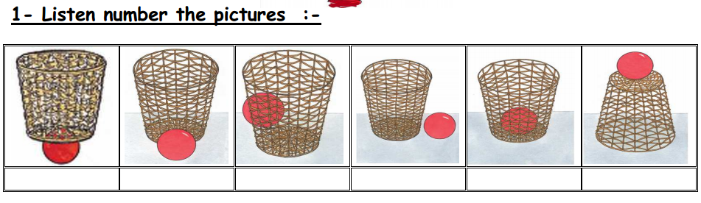

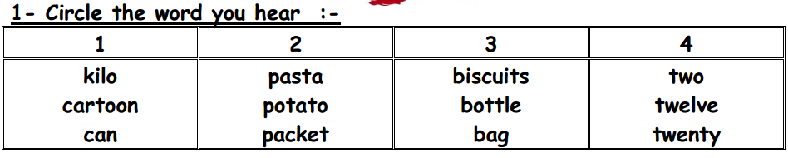

**3 - Match:**

1.  A carton of milk

 2. A bottle of water

3. A bag of pasta

4. A can of olives

5. A kilo of lemon

6. A packet of biscuits

4- write :

I'd like a can of olives, please .

------------------------------------------------------------------------------------------------------------------------------------------------------------------------------------------------------------------------------------------------------------------------------------------------------------------------------------------------------------------------------------------------------------------------------------------------------------------------------------------------------------------------------------------------------------------------------------------------------------------------------------------------------------------------------------------------------------------------------------------------------------------------------------------------------------------------------------------------------------------------------------------------------------------------------

**5- Look and Write :**

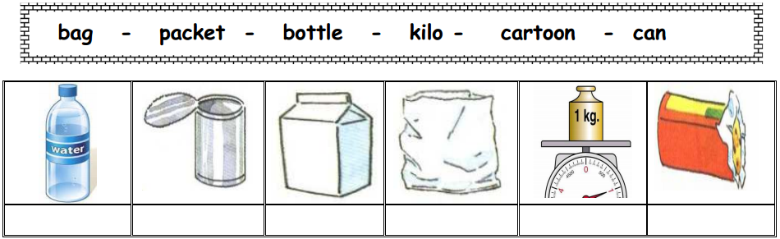

================================================================

**6- Match**

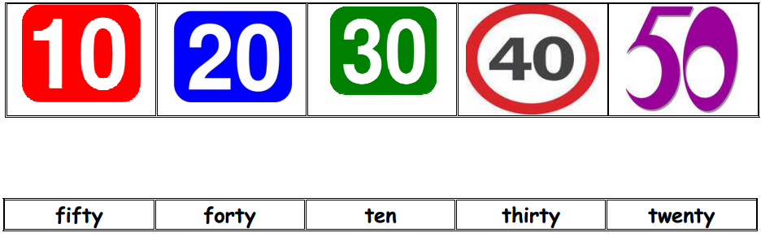

**7- Choose:**

1. It's a can of …………… ( potato – milk – tomatoes)
2. I'd ……………..a bag of rice , please.( like – bike – thank)
3. There are ………………..packets of biscuits.( six -seven )
4. How …………is it? Five dinars. ( many – much – old)
5. Ten plus twenty= ( sixty – seventy – thirty ) .

Teacher :

Talal Meawei