

**Palestine State**

**Ministry of Education**

**Directorate of Tulkarem**

**Nazlet Issa Basic Boys' School**

**Name:**

[**Class:3 rd Grade**](https://www.wepal.net/library/?app=content.list&level=3&semester=1&subject=5&type=2&submit=submit)

**Time:**

**Date:**

U-2 worksheet

------------------------------------------------------------------------------------------------------

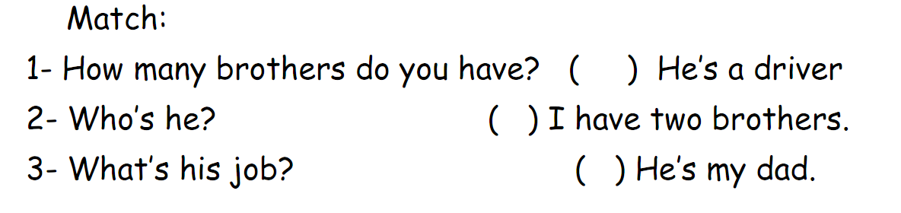

-------------------------------------------------------------------------------------------------------

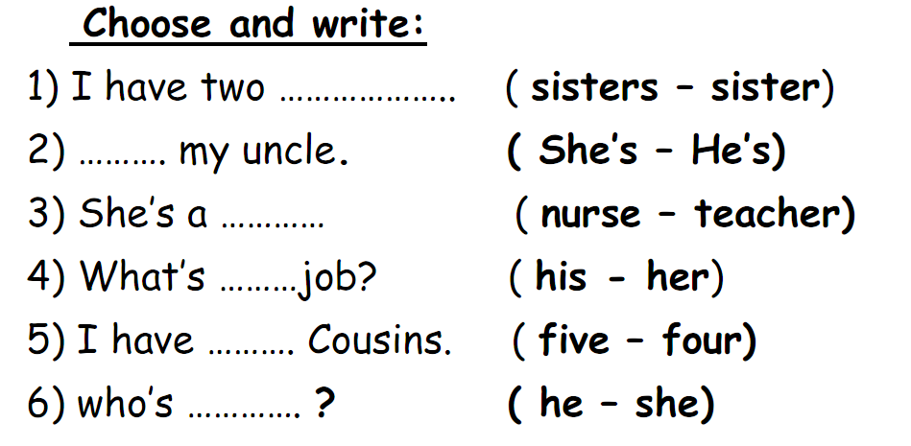

-------------------------------------------------------------------------------------------------------

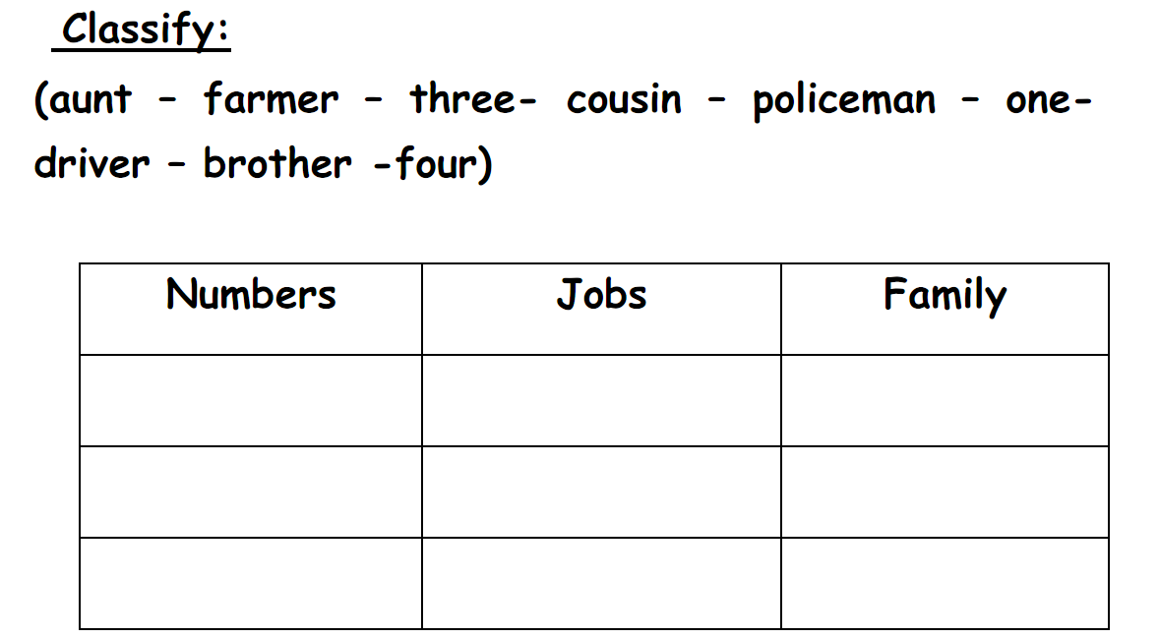

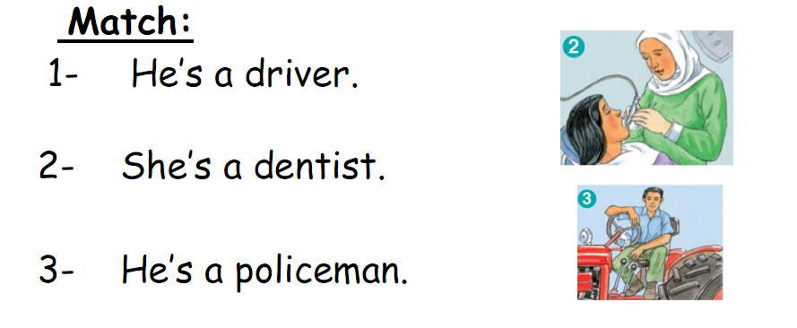

[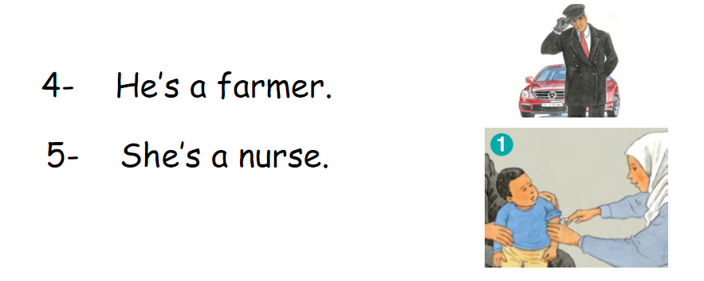](https://www.wepal.net/library/?app=content.list&level=3&semester=1&subject=5&type=2&submit=submit)

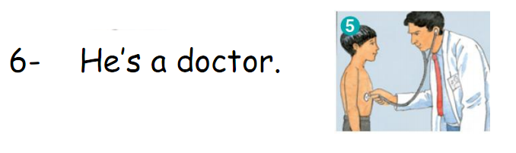

----------------------------------------------------------------------------------------------

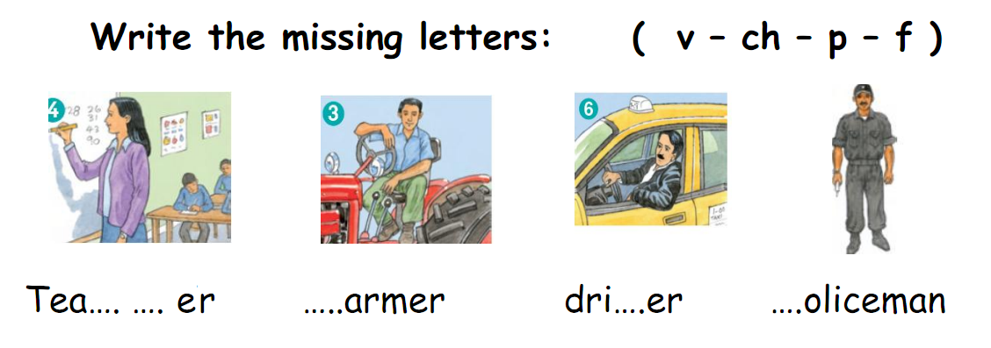

*********************************************************************

**The End**

**Good Luck Teacher: Akram Younis**