**بسم الله الرحمن الرحيم**

**مدرسة بنات إذنا الأساسية**

**Edna Basic school for girls**

**الصف الثاني**

**Second Grade**

**Worksheet**

**Listen and write**

**Hello! My name's Tala. I'm 8**

**What's your name?**

**How old are you?**

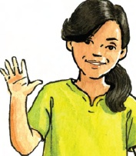

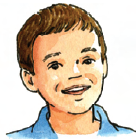

**My name's __________.   
I'm ___________.**

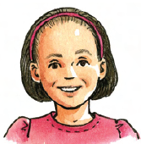

**My name's ______________.   
I'm ___________.**

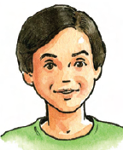

**My name's _______________.   
I'm ___________.**



**My name's ______________.**

**I'm ____________**

|  |
| --- |
| **Apple – nuts – fish –salad – chocolate – rice – ice cream – olives – orange – dates – kunafeh - chicken – melon-** |

**Read and write**

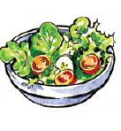 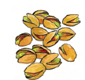 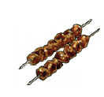 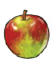 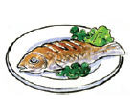

**___________ ________ ____________ ____________ ____________**

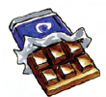 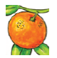 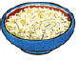 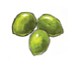 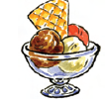

**_______________ ____________ ___________ __________ ____________**

 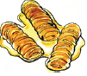 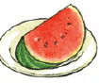 

**__________ __________________ ______________ __________________**

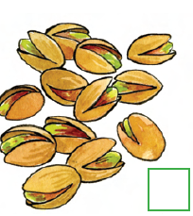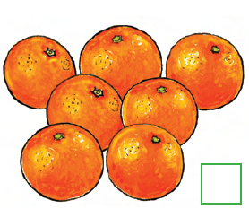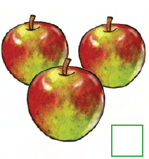**Count and write**

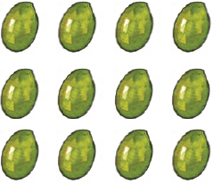



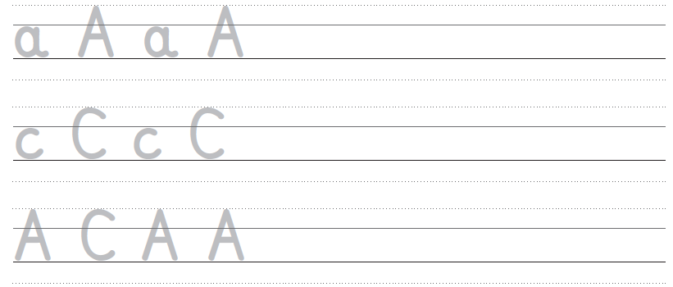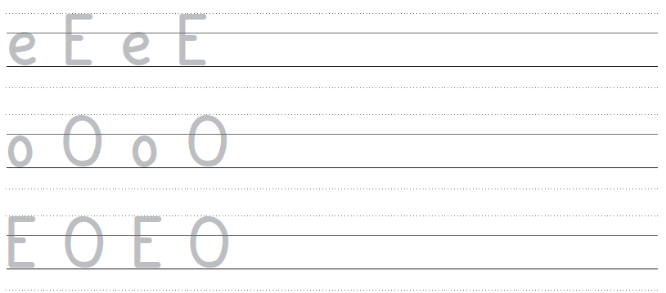**Trace and write**