|  |  |  |
| --- | --- | --- |
|  | | |
| Name ………………………………….. ;;.:………………………………………… |  | **Palestine ٍState of** |
| **Date : 13 \ 10 \ 2016** | **Ministry of Education & Higher Education** |
| **Class : 3rd class ( A )** | **Directorate of Education /Southern Hebron** |
|  | **Al-Farouq Boys Basic School** |
|  |  |  |

**1 )Listen and number the pictures :**



2) Read and match :

five 4

three 5

one 3

two 1

four 2

***3): Read and Match*** 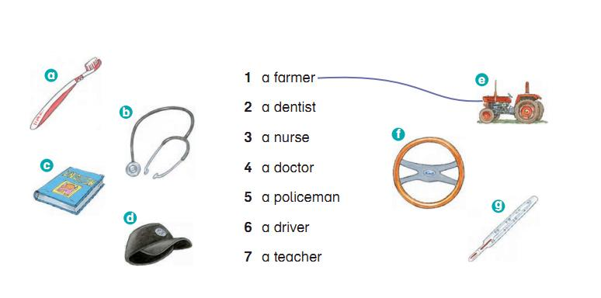

4) Rearrange :

* 1. father . - He's - my

………………………………………………………..

1. have - I - three – sisters .

…………………………………………………………………..

**5 ) Copy :**

**My father is a farmer .**

---------------------------------------------------------------------------------------------------------------------------------------------------------------------------------------------------------------------------------------------------------------------------------------------------------------------------------------------------------------------------------------------------------------------------------------------------------------------------------------------------------------------------------------------------------------------------------------------------

Teacher

Talal Meawei