**U--3**

**Palestine State**

**Ministry of Education**

**Directorate of Tulkarem**

**Nazlet Issa Basic Boys' School**

**Name:**

[**Class:4th Grade**](https://www.wepal.net/library/?app=content.list&level=4&semester=1&subject=5&type=2&submit=submit)

**Time:**

**Date:**

**-------------------------------------------------------------------------------------------------------------------**

**A) Read and answer the questions below:**

**My name is Huda. I'm reading a book in my bedroom. My mum**

**is in the kitchen. She's cooking. My dad is in the bathroom. He's**

**having a shower. My grandfather is reading a newspaper in the**

**garden. My brother, Ali is playing with his toys in the bedroom.**

**My grandmother is watching TV in the living room.**

**1) Put ( / ) or ( x ) :**

**1. Huda is sleeping in her bedroom. ( )**

**2. Mum is cooking in the living room. ( )**

**3. Dad is sleeping . ( )**

**4. Grandfather is reading a newspaper. ( )**

**5. Ali is playing with his toys. ( )**

**2) Circle the correct answer :**

**1. Huda is reading a ( book – newspaper )**

**2. Dad is in the ( bedroom – bathroom )**

**3. Grandfather is in the ( garden – living room)**

**Complete: ( watching TV - living room - Yassir - ten )**

**His name's ……………………...He's……………….. **

**He's ……………………..…….in the …………………….. .**

**1-Choose:**

**1. Mum's in (his – her) room.**

**2. He's having a shower in the ( bedroom – bathroom).**

**3. She's cooking in the (garden – kitchen)**

**4. Grandfather is (reading- sleeping) a newspaper.**

**5. Hamzah is (playing – watching) TV.**

**6. Hala's sleeping in the ( living room – bedroom).**

**7. He (is – are) playing.**

**8. They (is – are) in the garden.**

**9. Dad (aren't – isn’t) in our house.**

**10. Hala and Amal (isn't – aren't) swimming.-------------------------------------------------------------------------------------------------------------------------------**

[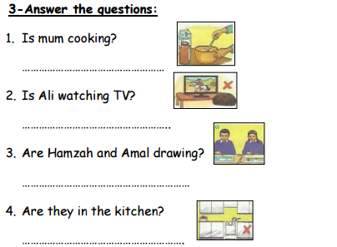](https://www.wepal.net/library/?app=content.list&level=4&semester=1&subject=5&type=2&submit=submit)

*************************************************************

The End T. Akram Younis Good Luck