**[4](https://www.wepal.net/library/?app=content.list&level=4&semester=2&subject=5&type=2)[th](https://www.wepal.net/library/?app=content.list&level=4&semester=2&subject=5&type=2) [Grade](https://www.wepal.net/library/?app=content.list&level=4&semester=2&subject=5&type=2)** [**Final Exam Second Semester**](https://www.wepal.net/library/?app=content.list&level=4&semester=2&subject=5&type=2)

**1.** [**Listen and circle**](https://www.wepal.net/library/?app=content.list&level=4&semester=2&subject=5&type=2)**.**

1. Hala adds **one** / **two** spoons of nuts.
2. Fiona is going to visit **Hebron** / **Bethlehem**.
3. She’s going to see **Mount Carmel** / **Church of the Nativity**
4. It's **eleven** / **eight** fifteen.
5. I **sometimes** / **never** do my homework at night.

**2. Listen and Complete.**

|  |  |  |  |
| --- | --- | --- | --- |
| **red socks** | **next to** | **drive** | **visit** |

1. I can’t __________________ a car.
2. Yesterday I bought _____________________
3. The tree is __________________ the house.
4. Bilal can play ________________________________-

**3. Write.**

|  |  |  |  |
| --- | --- | --- | --- |
| **do** | **holiday** | **No** | **visit** |

1. What are you going to do on ______________________
2. I’m going to __________________ Akka.
3. Do you _____________________ your homework in the morning?
4. ______________, I don’t.

**4. Raed and match.**

1. What can you do? ( ) I bought a CD.
2. Where's the bus stop? ( ) It's opposite the baker's.
3. What did you buy? ( ) I can play football.

**5. Read and circle.**

1. To make a cake we need { **flour** – **chicken** – **tomatoes** }
2. He's going to see Al-Ibrahimi { **Church** – **Mosque** – **Street** }
3. 10 + 10 + 10 + 5 = { **twenty-five** – **thirty-five** – **forty-five** }
4. He never { **go** – **goes** – **going** } to school on Fridays.

**6. Match with pictures.**

[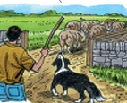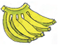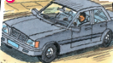](https://www.wepal.net/library/?app=content.list&level=4&semester=2&subject=5&type=2)

1. I helped my uncle 2. I went to greengrocer 3. I can drive a car

**7. Correct the underlined mistakes.**

1. He always **clean** his bedroom. ( _______________)
2. How **much** eggs? 6 eggs. ( _______________)
3. **In** Monday we are going to visit Jerusalem. ( __________ )

**8. Look and write.**

[](https://www.wepal.net/library/?app=content.list&level=4&semester=2&subject=5&type=2)

1. visit / going / to / Dome of the Rock. / the / I’m

_________________________________________________________

2. go / to / the / We’re / market. / going / to

__________________________________________________________

3. Dead Sea. / visit / the / going / to / I’m

__________________________________________________________

4. to / walk / going / in / the / old city. / We’re

____________________________________________________________

**9. Write.**

1. dance / dabka / we / can ___________________________________________________
2. make / a / he / can’t / cake __________________________________________________
3. **10. Write**

**[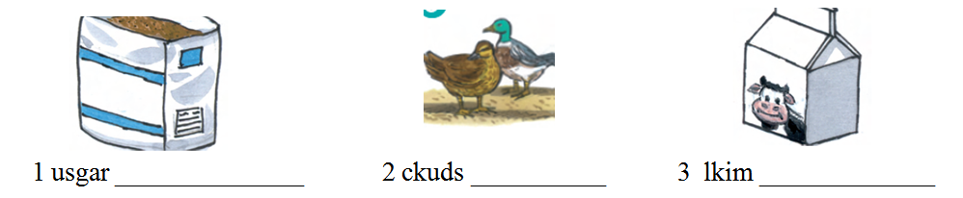](https://www.wepal.net/library/?app=content.list&level=4&semester=2&subject=5&type=2)**

**11. Write.**

|  |  |  |  |  |
| --- | --- | --- | --- | --- |
| **there** | **are** | **farm** | **Aren’t** | **ducks** |

On the _______________ there ________________ two brown horses and one white horse. On the farm _____________ are hens. There are _____________ too. But there _____________ sheep.

12. **Copy**

**H can’t play the drums**

للمزيد من امتحانات اللغة الانجليزية للصف الرابع الفصل الثاني

<https://www.wepal.net/library/?app=content.list&level=4&semester=2&subject=5&type=2>

_________________________