|  |  |  |
| --- | --- | --- |
|  | | |
| Name ………………………………….. ;;.:………………………………………… |  | **Palestine ٍState of** |
| **Date : 29 \ 10 \ 2015** | **Ministry of Education & Higher Education** |
| **Class : 3rd class ( A )** | **Directorate of Education /Southern Hebron** |
|  | **Al-Farouq Boys Basic School** |
|  |  |  |

1. Circle the word you hear :

1- Jerusalem Bethlehem Nablus Ramallah

2- girl boy children teacher

3- name old from five

4- father mother aunt uncle

5- chicken fish carrot banana

|  |
| --- |
|  |

|  |
| --- |
|  |

***2 ) Read and Match:*** 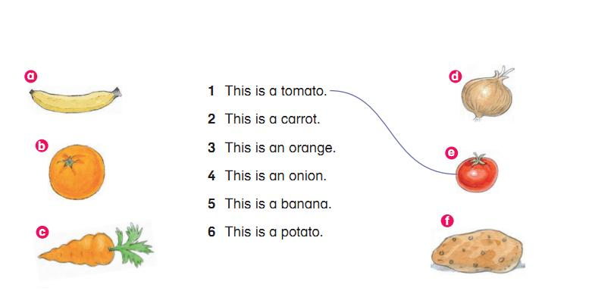

3) Match :



***4) Find and draw:*** 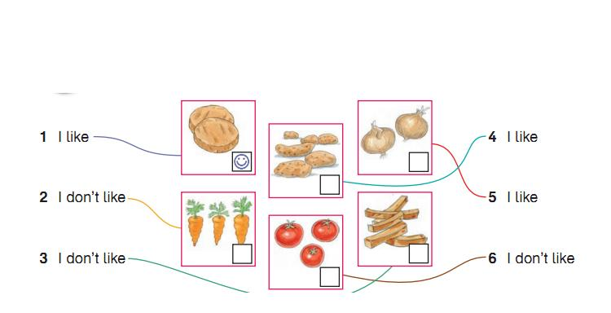

***----------------------------------------------------------------------------------***

**5). Match*:***

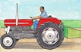***1 2 3 4 5 6 7***

***PAL-3-flashcards-007.bmpPAL-3-flashcards-005.bmp***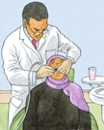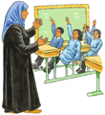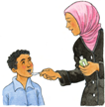

**policeman**

**farmer**

**dentist**

**doctor**

**nurse**

**driver**

**teacher**

**----------------------------------------------------------------------------------------------------------**

6 ) Write : I like chicken and apples .

----------------------------------------------------------------------------------------------------------------------------------------------------------------------------------------------------------------------------------------------------------------------------------------------------------------------------------------------------------------------------------------------------------------------------------------------------------------------------------------------------------------------------------------------------------------------------------------------------------------------------

Teacher :

Talal Meawei