Al-Mutasim Billah **Elem Boys B School**

**English Exam for fourth Grade –final**

**Name:………………………Class:…………………………**

______________________________________________________________________________________________________

**1-Listen and circle:** (listening)

a- mosque Bethlehem church mount

b- butter sugar flour Friday

c- fork nuts spoon sugar

d- Haifa Akka Hebron holiday

e- milk cake egg mix

______________________________________________________________________________________________________

**2- listen and number:**

[](https://www.wepal.net/library/?app=content.list&level=4&semester=2&subject=5&type=2)

______________________________________________________________________________________________________

**1-Complete the following dialogue :** (speaking)

Lina:Hello,………………………..

Thank - Excuse Hello - left baker - RanaWhere - bread

Rana: …………………………,Lina.

Lina:……………………. do you buy ……………….?

Rana: At the ………………………. .

Lina: ……………… me . Where is the baker?

Rana: It's on the ………………………….

Lina: ……………………………….. you.

______________________________________________________________________________________________________

**1-**[**Read the following passage and answer**](https://www.wepal.net/library/?app=content.list&level=4&semester=2&subject=5&type=2) **:-** (reading)

Lina's grandfather has a farm. It has a horse,ducks,cows, and sheep. Last Monday Lina's family went to the farm. Lina collected the eggs.

a- Put (/ ) or ( x ) :

1- Lina’s aunt has a farm ( ).

2- There are a horse,ducks,cows, and sheep in the farm ( ).

3- . Last Friday Lina’s family went to the farm ( ).

b- Answer:

1- When did Lina’s family go to the farm?

……………………………………………………………..

2- What did lina do there?

…………………………………………………………………….

**2-Match:**

a- We're going to visit the Dead Sea - to see the Mount Carmel.

b-I'm going to visit Haifa - to see the Church of the Nativity.

c-We're going to visit Jerusalem -to see Al-Jazzar Mosque.

d- I'm going to visit Akka -to swim in it.

e- I'm going to visit the Dead Sea -to visit the Dome of the Rock.

______________________________________________________________________________________________________

**1-**[**Order and write**](https://www.wepal.net/library/?app=content.list&level=4&semester=2&subject=5&type=2)**:** (writing)

a-never – bed – go – I – late

………………………………………………………………………………………………………

b-can – dance- We – dabka

……………………………………………………………………………………………………….

c- is - The – on – the – right – butcher's

……………………………………………………………………………………………………….______________________________________________________________________________________________________

**2-Classify:**

swimming– fox–giraffe –tennis –football– basketball – lion - horse

|  |  |
| --- | --- |
| Sports | Animals |
|  |  |
|  |  |
|  |  |
|  |  |

______________________________________________________________________________________________________

**3-Write:**

**[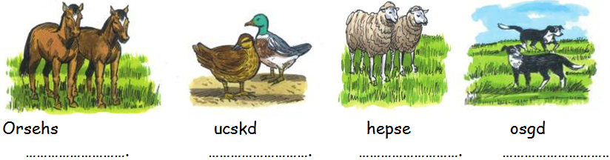](https://www.wepal.net/library/?app=content.list&level=4&semester=2&subject=5&type=2)**

**4-Handwriting:**

Jerusalem is the capital of Palestine .

____________________________________________________________________________________________________________________________________________________________________________________________________________________________________________________________________________________________________________________________________________________________________________________________________________________________________________________________________________________

للمزيد من امتحانات اللغة الانجليزية للصف الرابع الفصل الثاني

<https://www.wepal.net/library/?app=content.list&level=4&semester=2&subject=5&type=2>