

**Name:**

[**Class:2nd Grade**](https://www.wepal.net/library/?app=content.list&level=2&semester=1&subject=5&type=2&submit=submit)

**Tim e:**

**Date:**

**Palestine State**

**Ministry of Education**

**Directorate of Tulkarem**

**Nazlet Issa Basic Boy**

**s' School**

U-1

-------------------------------------------------------------------------------------------------------

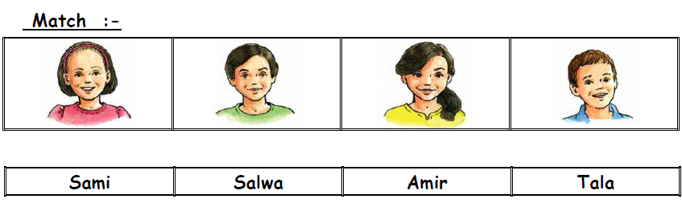

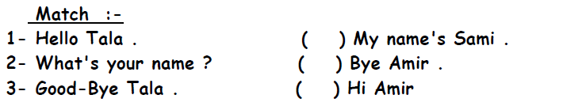

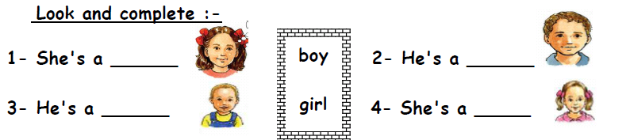

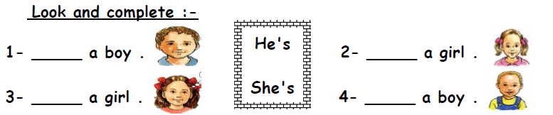

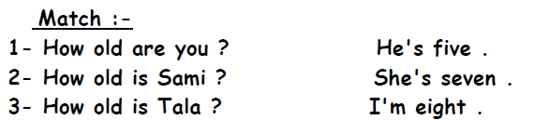

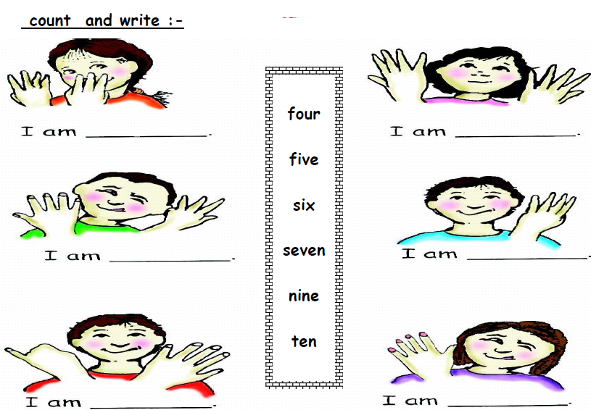

[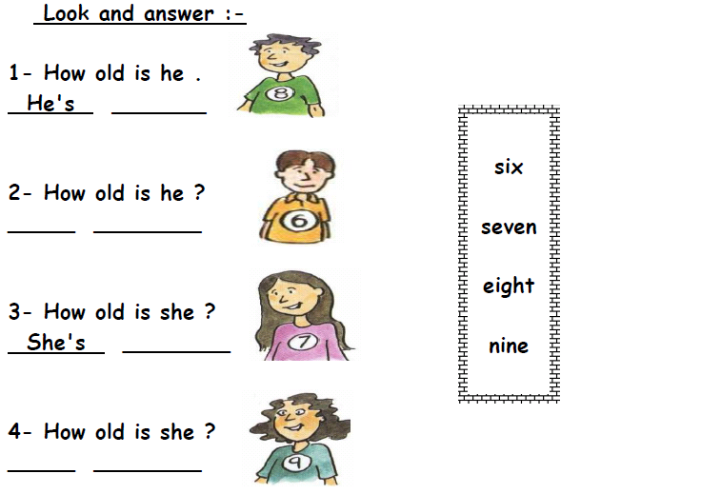](https://www.wepal.net/library/?app=content.list&level=2&semester=1&subject=5&type=2&submit=submit)

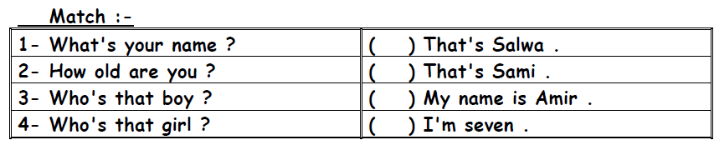

[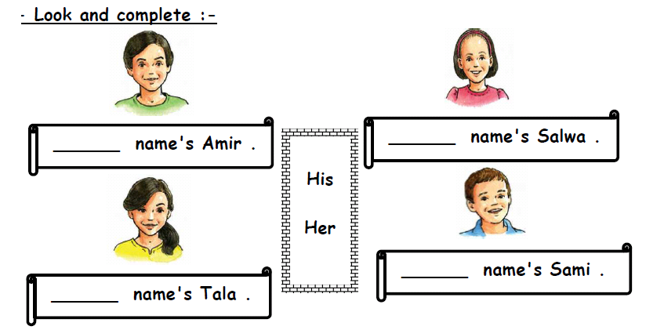](https://www.wepal.net/library/?app=content.list&level=2&semester=1&subject=5&type=2&submit=submit)

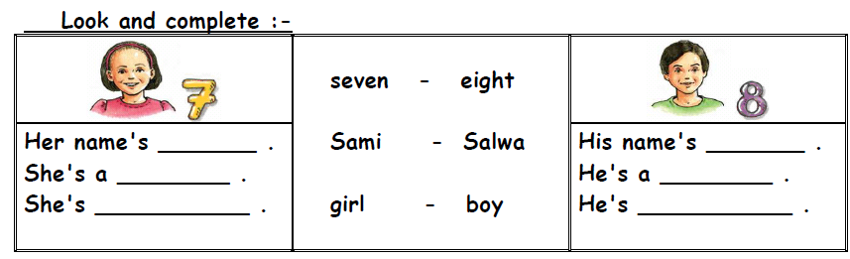

*********************************************************************

**The End**

**Good Luck Teacher: Akram Younis**