

دولة فلسطين

وزارة التربية والتعليم العالي

مديرية التربية والتعليم في محافظة :

سجل العلامات المدرسية

للعام الدراسي

**2020 - 2021 م**

**1441 - 1442 هـ**

وفق تعليمات أسس النجاح والإكمال والرسوب الجديد

البلدة:

المدرسة:

الصف:

المباحث:

اسم المعلم/ة :

[الفصل الدراسي الأول](https://www.wepal.net/library/)

المبحث: الصف: الشعبة: ( )

|  |  |  |  |  |  |  |  |  |
| --- | --- | --- | --- | --- | --- | --- | --- | --- |
| **الرقم** | **اسم الطالب/ة** | **الفترة الأولى** | | | **الفترة الثانية** | | | **المجموع النهائي** |
| **تقويم أصيل** | **امتحان الفترة** | **المجموع** | **تقويم أصيل** | **امتحان الفترة** | **المجموع** |
| **خاص بالصفوف (5-11)** | **5%** | **20%** | **25%** | **5%** | **20%** | **25%** | **50%** |
| **خاص بالصف (12) بكافة فروعه** | **5%** | **25%** | **30%** | **5%** | **25%** | **30%** | **60%** |
| **1** |  |  |  |  |  |  |  |  |
| **2** |  |  |  |  |  |  |  |  |
| **3** |  |  |  |  |  |  |  |  |
| **4** |  |  |  |  |  |  |  |  |
| **5** |  |  |  |  |  |  |  |  |
| **6** |  |  |  |  |  |  |  |  |
| **7** |  |  |  |  |  |  |  |  |
| **8** |  |  |  |  |  |  |  |  |
| **9** |  |  |  |  |  |  |  |  |
| **10** |  |  |  |  |  |  |  |  |
| **11** |  |  |  |  |  |  |  |  |
| **12** |  |  |  |  |  |  |  |  |
| **13** |  |  |  |  |  |  |  |  |
| **14** |  |  |  |  |  |  |  |  |
| **15** |  |  |  |  |  |  |  |  |
| **16** |  |  |  |  |  |  |  |  |
| **17** |  |  |  |  |  |  |  |  |
| **18** |  |  |  |  |  |  |  |  |
| **19** |  |  |  |  |  |  |  |  |
| **20** |  |  |  |  |  |  |  |  |
| **21** |  |  |  |  |  |  |  |  |
| **22** |  |  |  |  |  |  |  |  |
| **23** |  |  |  |  |  |  |  |  |
| **24** |  |  |  |  |  |  |  |  |
| **25** |  |  |  |  |  |  |  |  |
| **26** |  |  |  |  |  |  |  |  |
| **27** |  |  |  |  |  |  |  |  |
| **28** |  |  |  |  |  |  |  |  |
| **29** |  |  |  |  |  |  |  |  |
| **30** |  |  |  |  |  |  |  |  |
| **31** |  |  |  |  |  |  |  |  |
| **32** |  |  |  |  |  |  |  |  |
| **33** |  |  |  |  |  |  |  |  |
| **34** |  |  |  |  |  |  |  |  |
| **35** |  |  |  |  |  |  |  |  |
| **36** |  |  |  |  |  |  |  |  |
| **37** |  |  |  |  |  |  |  |  |
| **38** |  |  |  |  |  |  |  |  |
| **39** |  |  |  |  |  |  |  |  |
| **40** |  |  |  |  |  |  |  |  |

[الفصل الدراسي الثاني](https://www.wepal.net/library/?app=content.list&level=4&semester=1&subject=1&type=2&submit=submit)

**المعدل السنوي يساوي معدل الفصل الأول مضافاً إليه معدل الفصل الثاني**

المبحث: الصف: الشعبة: ( )

|  |  |  |  |  |  |  |  |  |  |  |
| --- | --- | --- | --- | --- | --- | --- | --- | --- | --- | --- |
| **الرقم** | **الفترة الثالثة** | | | **الفترة الرابعة** | | | **معدل الفصل الثاني** | **المعدل السنوي** | **ملحوظات** | **علامة الإكمال** |
| **تقويم أصيل** | **امتحان الفترة** | **المجموع** | **تقويم أصيل** | **امتحان الفترة** | **المجموع** |
| **5%** | **20%** | **25%** | **5%** | **20%** | **25%** | **50%** | **100%** | **صفوف 5-11** |
| **5%** | **35%** | **40%** | **---------** | **---------** | **---------** | **40%** | **100%** | **صف 12** |
| **1** |  |  |  |  |  |  |  |  |  |  |
| **2** |  |  |  |  |  |  |  |  |  |  |
| **3** |  |  |  |  |  |  |  |  |  |  |
| **4** |  |  |  |  |  |  |  |  |  |  |
| **5** |  |  |  |  |  |  |  |  |  |  |
| **6** |  |  |  |  |  |  |  |  |  |  |
| **7** |  |  |  |  |  |  |  |  |  |  |
| **8** |  |  |  |  |  |  |  |  |  |  |
| **9** |  |  |  |  |  |  |  |  |  |  |
| **10** |  |  |  |  |  |  |  |  |  |  |
| **11** |  |  |  |  |  |  |  |  |  |  |
| **12** |  |  |  |  |  |  |  |  |  |  |
| **13** |  |  |  |  |  |  |  |  |  |  |
| **14** |  |  |  |  |  |  |  |  |  |  |
| **15** |  |  |  |  |  |  |  |  |  |  |
| **16** |  |  |  |  |  |  |  |  |  |  |
| **17** |  |  |  |  |  |  |  |  |  |  |
| **18** |  |  |  |  |  |  |  |  |  |  |
| **19** |  |  |  |  |  |  |  |  |  |  |
| **20** |  |  |  |  |  |  |  |  |  |  |
| **21** |  |  |  |  |  |  |  |  |  |  |
| **22** |  |  |  |  |  |  |  |  |  |  |
| **23** |  |  |  |  |  |  |  |  |  |  |
| **24** |  |  |  |  |  |  |  |  |  |  |
| **25** |  |  |  |  |  |  |  |  |  |  |
| **26** |  |  |  |  |  |  |  |  |  |  |
| **27** |  |  |  |  |  |  |  |  |  |  |
| **28** |  |  |  |  |  |  |  |  |  |  |
| **29** |  |  |  |  |  |  |  |  |  |  |
| **30** |  |  |  |  |  |  |  |  |  |  |
| **31** |  |  |  |  |  |  |  |  |  |  |
| **32** |  |  |  |  |  |  |  |  |  |  |
| **33** |  |  |  |  |  |  |  |  |  |  |
| **34** |  |  |  |  |  |  |  |  |  |  |
| **35** |  |  |  |  |  |  |  |  |  |  |
| **36** |  |  |  |  |  |  |  |  |  |  |
| **37** |  |  |  |  |  |  |  |  |  |  |
| **38** |  |  |  |  |  |  |  |  |  |  |
| **39** |  |  |  |  |  |  |  |  |  |  |
| **40** |  |  |  |  |  |  |  |  |  |  |

[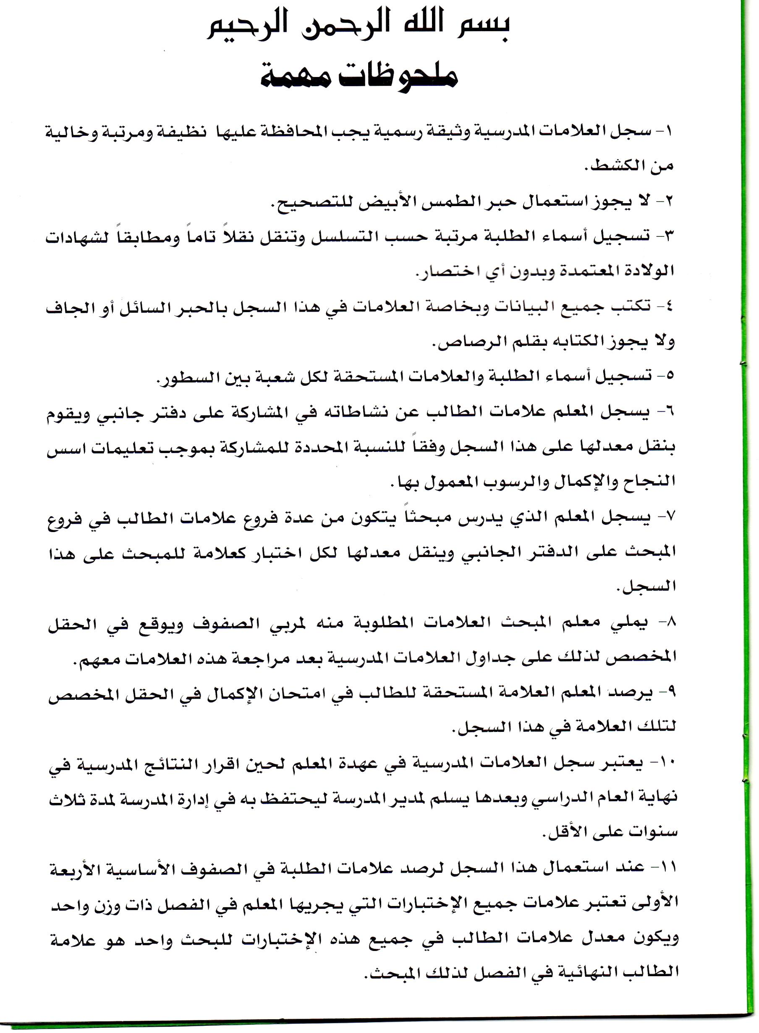](https://www.wepal.net/library/)