|  |  |  |
| --- | --- | --- |
| **Name:**  [**Class:1st Grade**](https://www.wepal.net/library/?app=content.list&level=1&semester=1&subject=5&type=2&submit=submit)  **Date:** | **[فلسطين](https://www.wepal.net/library/?app=content.list&level=1&semester=1&subject=5&type=2&submit=submit)**  **الفصل الدراسي الأول**  **2020/2021م** | **Palestine State**  **Ministry of Education**  **Directorate of Tulkarm**  **Nazlat Issa Basic Boys' School** |

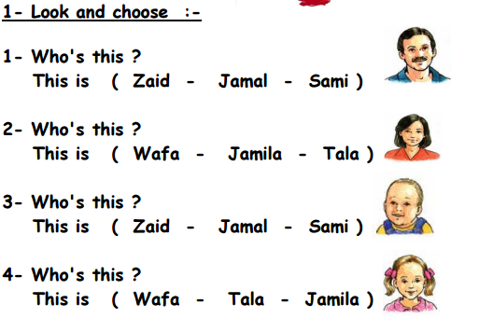

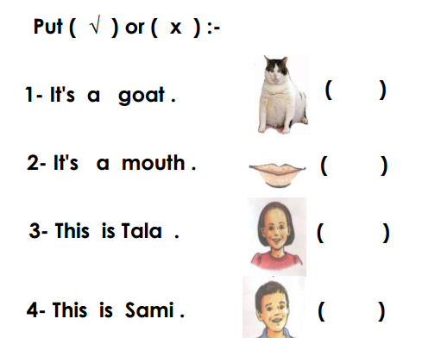

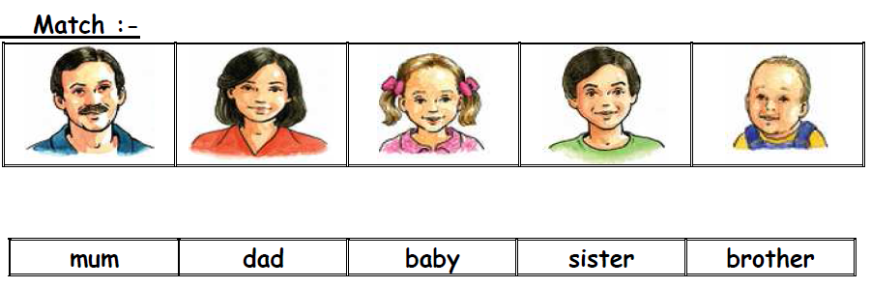

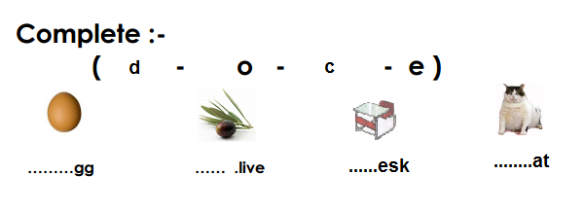

[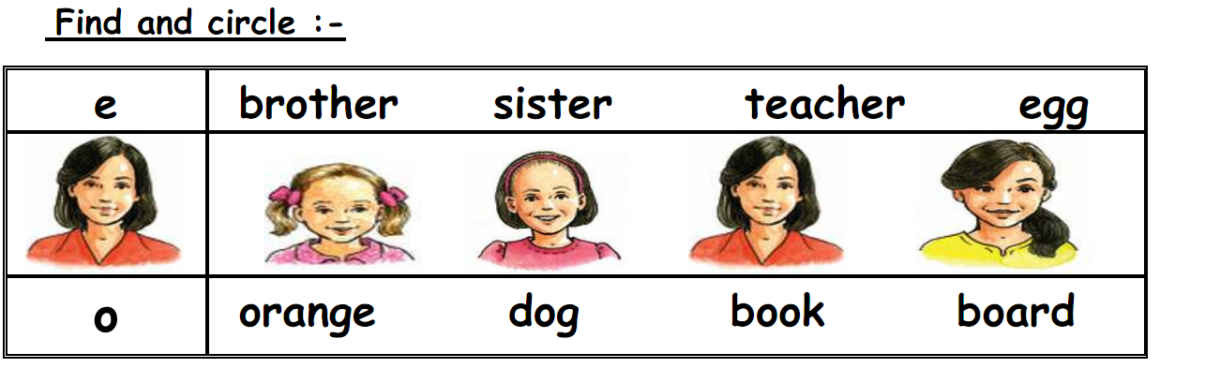](https://www.wepal.net/library/?app=content.list&level=1&semester=1&subject=5&type=2&submit=submit)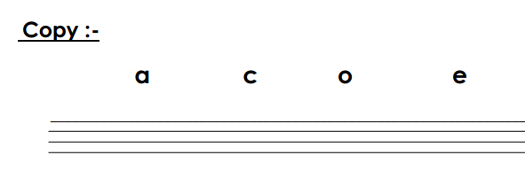

_____________________________________________________

The End T. Akram YounisGood Luck