دولة فلسطين  وزارة التربية والتعليم العالي  مديرية التربية والتعليم قلقيلية  ذكور كفر قدوم الاساسية |  | State of Palestine  Ministry of Education and Higher Education  Director of Education/Qalqilya  Kuffer Qadoom basic boy's school
Grade : 2nd Worksheet ( unit 7 ) Date : \ \ 2015
Teacher : Tha'er Z. Taha Name:______________________
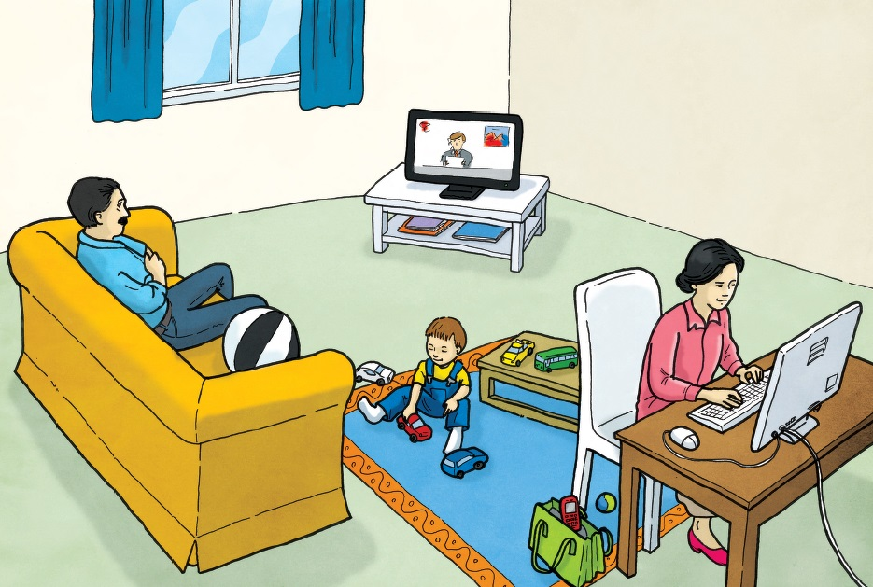
- Look and answer.

- The telephone is _____ the bag. B- The ball is _____ the sofa.
C- The rug is __________ the chair. D- the computer is _____ the table.

2- Trace and write.
