Name : | 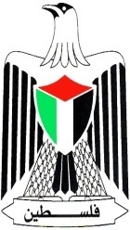 | State of Palestine
Class: 3rd ( A ) |  | Ministry of Education & Higher Education
Date : 17 / 11 / 2016 |  | Directorate of Education / Southern Hebron
 |  | Al-Farouq Boys Basic School
1- Listen and circle the word you hear : ( 4 points )
1-potatoes tomatoes carrots melons
2- doctor nurse farmer driver
3- father mother brother uncle
4- four five fourteen fifteen

2. Match: ( 6 points)
tomato carrot tiger teacher farmer fox

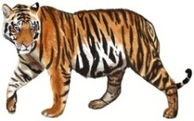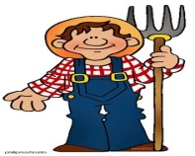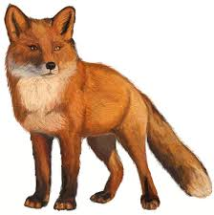

3. Complete the sentences ( 4 points)
black big fast no
- The snake has ______ legs .
- My favorite colour is __________.
- The elephant is very __________.
- The monkey runs __________.

- Read and circle ( 2 points)
- I like / don’t like oranges.
b. I like / don’t like snakes.
5) Circle :- ( 2 points)

1- I am small . I have two legs . I am fast . What am I ?......................
( giraffe – monkey – snake )

2- I am very big . I have four legs . I am slow . I am grey . What am I ?......................
( tiger – snake – elephant

6-Count and write the numbers : ( 4 points )
-  ________ bananas.
-  _________ ice-creams
- 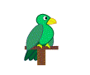 _________ parrots.
-  _________grapes

7 – Write (3 points)

I can see a fox . It has four legs .
_____________________________________________________________________________________________________
_____________________________________________________________________________________________________
_____________________________________________________________________________________________________
_____________________________________________________________________________________________________

Teacher : Talal Meawei

