Name :----------------------------------- | 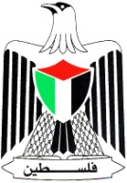 | Palestinian National Authority
Class: 4th ( A -- B -- C ) |  | Ministry of Education & Higher Education
Date : \ 11 \ 2016 |  | Directorate of Education /Southern Hebron
------ |  | Al-Farouq Boys Basic School
د\\\ؤفمغ ...الاسم:..................................................

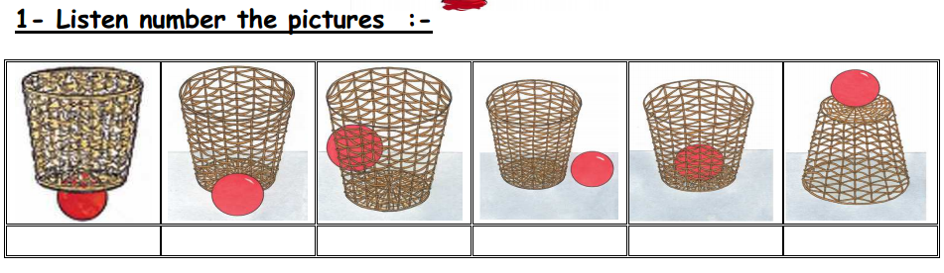
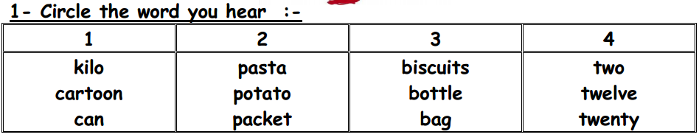

3 - Match:

- A carton of milk
2. A bottle of water
3. A bag of pasta
4. A can of olives
5. A kilo of lemon
6. A packet of biscuits

4- write :

I'd like a can of olives, please .
------------------------------------------------------------------------------------------------------------------------------------------------------------------------------------------------------------------------------------------------------------------------------------------------------------------------------------------------------------------------------------------------------------------------------------------------------------------------------------------------------------------------------------------------------------------------------------------------------------------------------------------------------------------------------------------------------------------------------------------------------------------------------------------------------------------------------------------------------------------------------------------------------------------------------

5- Look and Write :
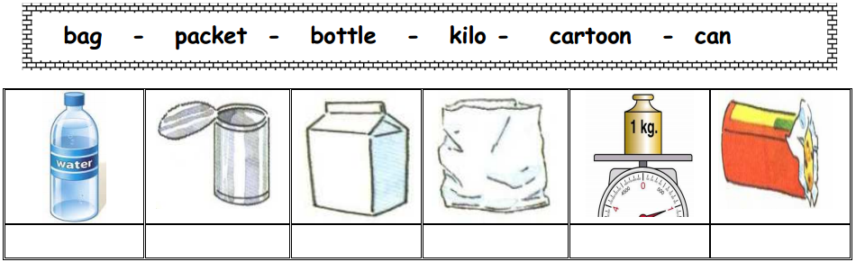
================================================================

6- Match
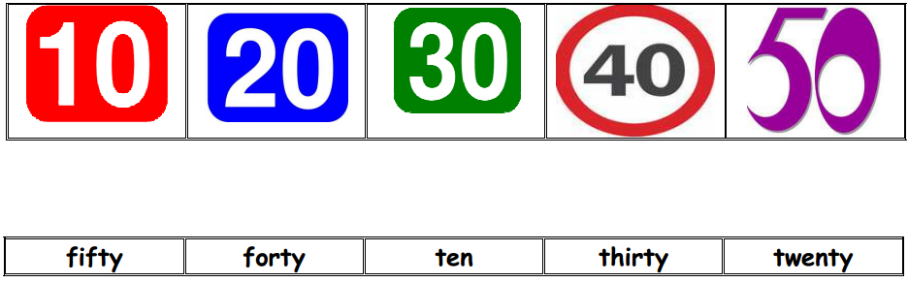

7- Choose:
- It's a can of …………… ( potato – milk – tomatoes)
- I'd ……………..a bag of rice , please.( like – bike – thank)
- There are ………………..packets of biscuits.( six -seven )
- How …………is it? Five dinars. ( many – much – old)
- Ten plus twenty= ( sixty – seventy – thirty ) .

Teacher :
Talal Meawei

