________________________Name : |  | PalestineٍState of
Class: 5th ( A -- B -- C ) |  | Ministry of Education & Higher Education
Date : 22 \ 11 \ 2016 |  | Directorate of Education /Southern Hebron
------ |  | Al-Farouq Boys Basic School
د\\\ؤفمغ ...الاسم:..................................................

1- Read and answer :
The season of autumn is windy .The months of September,October , and November are in Autumn . We can fly our kites in October .Amy and Rania look at the internet .They look at the Spring flowers . Spring is in the months of March, April and May .

1-Read and write ( ) or ( X
1-- The season of autumn is very hot . ( )
2- Amy and Rania can fly a kite in autumn . ( )
3- They look at the spring flowers in spring . ( )

2- Complete .
a-September , October and ----------------- are in -----------
b- We can fly our kites in ------------------.

3- Answer .
1- When's Spring ?
-----------------------------------------------------------------------------
2-What can we do in October ?
-----------------------------------------------------------------------------
3-Why does Omer fly his kite in Autumn ?
-----------------------------------------------------------------------------
3- Choose and complete
October year winter summer

1-June ,July and August are months of ------------------.
2- In --------------------we pick olives .
3- There are twelve months in the ------------------
4- The -----------------months are December , January and February.

4- W rite
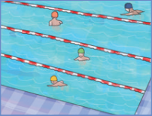
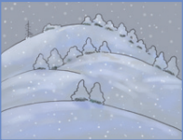


atmunu 2- wr ntei 3- msmure
_________ _________ __________
5- Read and answer .
What do you do every day ?
1-- I --------------------( wash ) my hands .

2- I------------------(-make ) my bed .

What does she do every day?

3- She ---------------( go ) to school .

4- She --------------( clean ) her bedroom .

6- Choose :
1- We like summer ( or - and ) autumn .
2- It is snowy ( in -on ) December .
3- February has ( 30 - 28 ) days .
4- Omar can ( pick - picking ) olives in October .
5- Everyday I ( wash - washes ) my head
6- She ( ride - rides ) her bike every day .

7- Copy .
January February March April

----------------------------------------------------------------------------------------------------------------------------------------------------------------------------------------------------------------------------------------------------------------------------------------------------------------------------------------------------------------------------------------------------------------------------------------------------------------------------------------------------------------

Teacher
Talal Meawei

