Name ………………………………….. ;;.:………………………………………… | 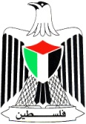 | Palestine ٍState of
Date : 29 \ 10 \ 2015 |  | Ministry of Education & Higher Education
Class : 3rd class ( A ) |  | Directorate of Education /Southern Hebron
 |  | Al-Farouq Boys Basic School
- Circle the word you hear :
1- Jerusalem Bethlehem Nablus Ramallah
2- girl boy children teacher
3- name old from five
4- father mother aunt uncle
5- chicken fish carrot banana

2 ) Read and Match: 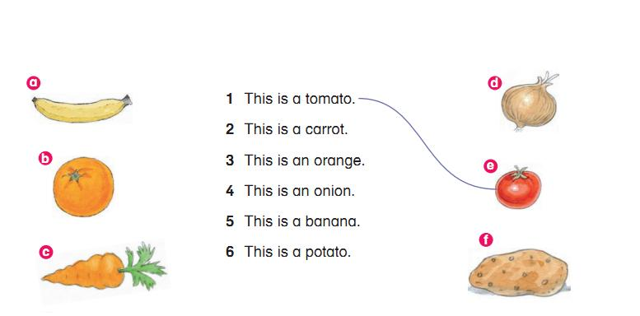
3) Match :

4) Find and draw: 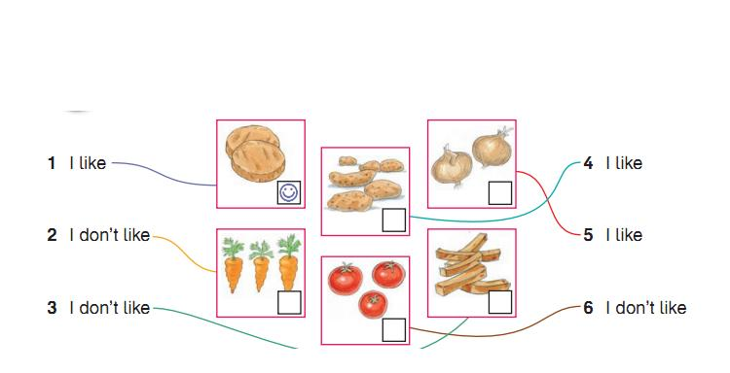
5). Match:




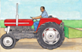
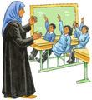
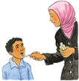
1 2 3 4 5 6 7

farmer
doctor
nurse
driver
teacher
policeman
dentist

_______________________________________________________________________
6 ) Write : I like chicken and apples .
----------------------------------------------------------------------------------------------------------------------------------------------------------------------------------------------------------------------------------------------------------------------------------------------------------------------------------------------------------------------------------------------------------------------------------------------------------------------------------------------------------------------------------------------------------------------------------------------------------------------------

Teacher :Talal Meawei

