Name ………………………………….. ;;.:………………………………………… | 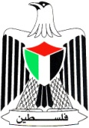 | Palestine ٍState of
Date : 13 \ 10 \ 2016 |  | Ministry of Education & Higher Education
Class : 3rd class ( A ) |  | Directorate of Education /Southern Hebron
 |  | Al-Farouq Boys Basic School
1 )Listen and number the pictures :
2) Read and match :
five 4
three 5
one 3
two 1
four 2

3): Read and Match 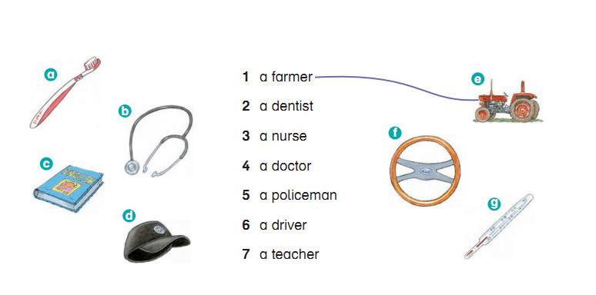

4) Rearrange :
  - father . - He's - my

………………………………………………………..
- have - I - three – sisters .

…………………………………………………………………..

5 ) Copy :

My father is a farmer .

---------------------------------------------------------------------------------------------------------------------------------------------------------------------------------------------------------------------------------------------------------------------------------------------------------------------------------------------------------------------------------------------------------------------------------------------------------------------------------------------------------------------------------------------------------------------------------------------------

Teacher
Talal Meawei

