Name :----------------------------------- | 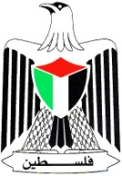 | Palestinian National Authority
Class: 5th ( A -- B -- C ) |  | Ministry of Education & Higher Education
Date : 1 7 \ 11 \2016 |  | Directorate of Education /Southern Hebron
 |  | Al-Farouq Boys Basic School
د\\\ؤفمغ ...الاسم:..................................................
1-Complete :
January ---- February ----- March ---- April
May ------ June --------- July ----- August
September --- October ------- November --- December
-----------------------------------------------------------------------------
winter | spring | summer | autumn

Teacher : Talal Meawi

