Name : | 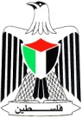 | State of Palestine
Class: 1st class ( A ) |  | Ministry of Education & Higher Education
Date : 17 / 11 / 2016 |  | Directorate of Education / Southern Hebron
 |  | Al-Farouq Boys Basic School

My body

❤look and say :

❤Look and match :

❤ count and write :
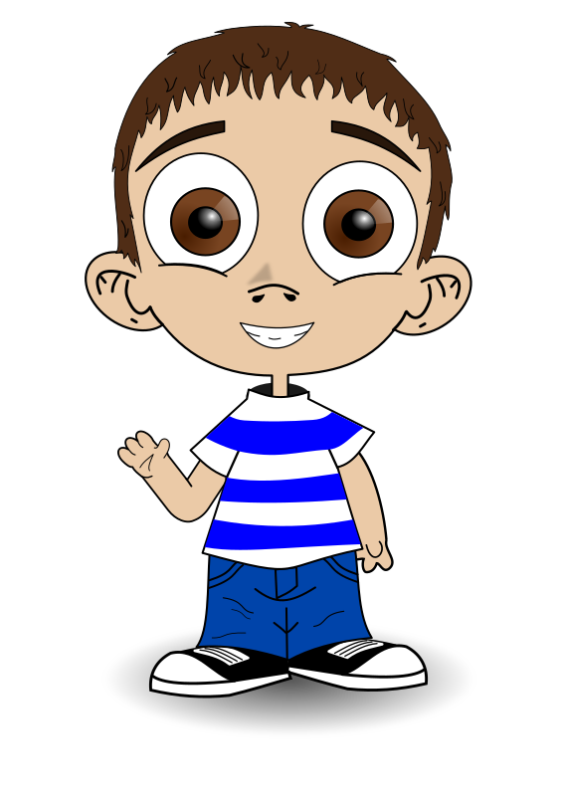
________________________________

✏How many eyes?

________________________________
✏How many heads?

________________________________
_________
________________________________

✏How many mouths? ✏How many hands?

________________________________
________________________________

✏How many noses? ✏ How many legs?

