دولة فلسطين  وزارة التربية والتعليم العالي  مديرية التربية والتعليم قلقيلية  ذكور كفر قدوم الاساسية | 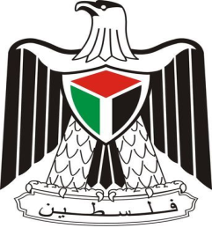 | State of Palestine  Ministry of Education and Higher Education  Director of Education/Qalqilya  Kuffer Qadoom basic boy's school
Grade: 4th Worksheet (unit 10) Date : \ \ 2016
Teacher: Tha'er Z. Taha Name: ______________________
1- Match.
❶ We’re going to visit Jerusalem. ( ) to see Al-Ibrahimi mosque.
❷ We’re going to visit Qalqilya. ( ) I’m going to swim.
❸ We’re going to visit Hebron. ( ) to see the Dome of the Rock.
❹ I’m going to visit the Dead sea. ( ) to see the zoo.

2- Re-arrange.
① Sunday – going – I’m – to – Akka – visit – on.
________________________________________________________________
② The church of the Nativity – We’re – visit – on – see – going – to – Thursday.
___________________________________________________________________

3- Choose the correct answer.
₁. We ( is – are ) going to visit Haifa.
₂. I’m going ( in – to ) visit Jerusalem.

4- Odd one out.
a- Akka Haifa Palestine Bethlehem
b- Visit Mount Carmel swim see

