بسم الله الرحمن الرحيم
مدرسة بنات إذنا الأساسية
Edna Basic school for girls
الصف الثاني
Second Grade
Worksheet

Listen and write
Hello! My name's Tala. I'm 8
What's your name?
How old are you?

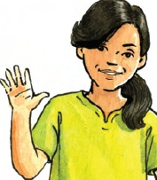


My name's __________.
I'm ___________.

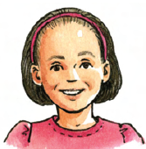
My name's ______________.
I'm ___________.

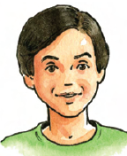
My name's _______________.
I'm ___________.


My name's ______________.
I'm ____________

Apple – nuts – fish –salad – chocolate – rice – ice cream – olives – orange – dates – kunafeh - chicken – melon-
Read and write
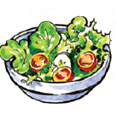
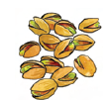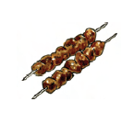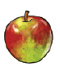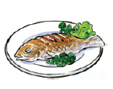
___________ ________ ____________ ____________ ____________
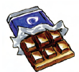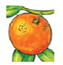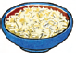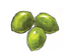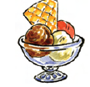
_______________ ____________ ___________ __________ ____________

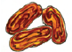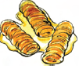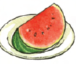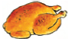
__________ __________________ ______________ __________________

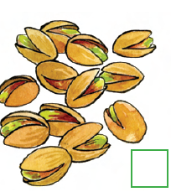
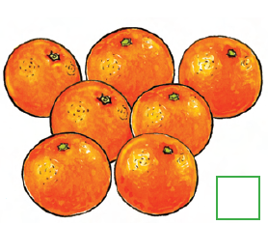
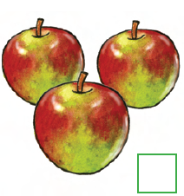
Count and write
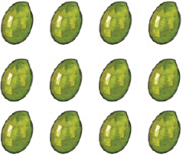


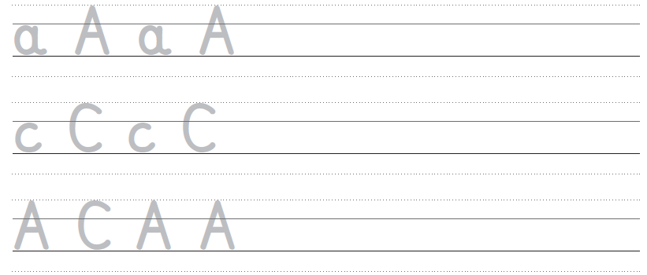
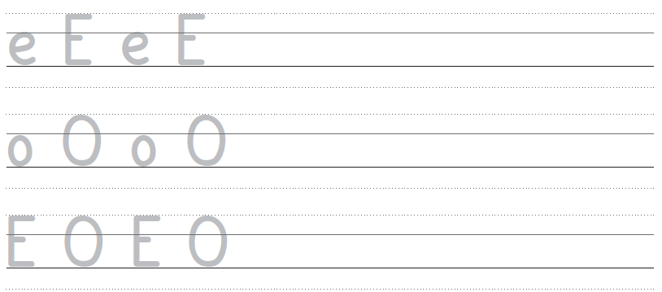
Trace and write

