Class: 6th Grade  Date:9/2/2015  الوحدة 10 الفصل الثاني  Name:…………………… |  | State of Palestine  Ministry of Education  Directorate of Education – Jenin  Selih Harthiah BasicGirls' School

Read the following text , then answer the questions : Q1)

Amy and Ranai are looking at the internet .They have found the Dead Sea. Rania visited the Dead Sea two years ago .The man in the picture is floating and reading a newspaper !

Amy ,Rania and Ben are looking at pictures of the Dead sea .The water is very salty . There are no fish or plants in the sea. Some plants can grow between rocks . Palm trees grow in an oasis because water comes from a spring .
People put mud on their bodies . The mud is a medicine for your skin .
The Dead Sea is 400 meters below sea level .There are many desert animals near the sea . Gazelles and jerboas

******************************

- Tick the correct sentences :
- The water in an oasis comes from a spring . ……
- You can float in the Dead Sea. ……
3-The Dead Sea is 40 meters below sea level . ……

- Complete the sentences :
- Rania visited ……………… two years ago .
- ……………………grow in an oasis .

- Why are there no fish or plants in the Dead Sea ?
………………………………………………………..

- Where can some plants grow ?
………………………………………………………..

- Why do people put Dead Sea mud on their skin ?
........................................................................................

- What animals live in the desert?
……………………………………………………………..

- Does anything live in the Dead Sea ?
..............................................................................................

Q2) Match words with pictures :

rocks…..spring ……..palm trees……..oasis………man

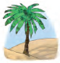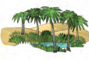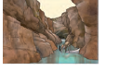

……… ………. ………….. …….. ……...

Q3)Complete the questions :

1-Have you ever flown in a plane ?
2-……..Huda ever ……….(fall) of a bike ?
3-…………they ever …………..(ride) a camel?
4-…………….Maher ever …………(climb) a tree ?

Q4) Choose the correct answer :

1-Have you ever seen / see a jerboa ?
2- Have you ever been / be to an oasis ?
3-Have you ever drink / drunk a water from a spring ?

Q5) Write correct sentences :

1-have you ever floated in the sea
…………………………………………………………………………

2-yes i have ive floated and painted a picture
…………………………………………………………………………
Q6)Listen and choose the correct answer :
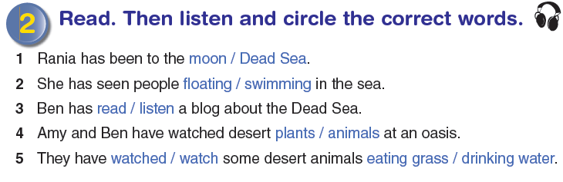
-----------------------------------------------------------------------------------------

Teacher : Mesa'dih Badarnih Good luck

