Sixth grade .
Name :---------------------.
Date :-- ---/3/2015----.
UNIT 12
At the clinic
Work sheet
- Order and write correct word :
  - eezsne:-------------------------.
  - ugb:-----------------------.
  - cheaera:------------------.
  - ulf:-------------------------.
  - Thorat orse:-------------------------.
- Mach the word with the picture :
Backache
 cough 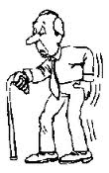 thirsty
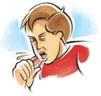
fever
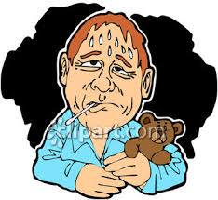
cold
- Decide whether the following sentences are (T) or (F) :
- Ben has backache and cough ( ).
2. there are 7 students in the class ( )
3. Rania has a sore throat ( ).
4. the children has to stay at school until they become well ( )
- Read and complete the sentences :
1. Ben and Amy were in the --------- they were very --------------- .
2. Omar has --------------- and a ------------------- .
3.there was a --------------------- ------------- going around .
4. Mr Ali says there is a ----------- ----------------- going around .
5. Amy has a ----------------- .
5. Read the sentences then circle the correct word:
- Amy and Ben have been sick ( since /before ) yesterday .
- There is a ( a stomach /earache ) going around .
- Ben has been (coughing /sneezing ) all day .
6. Read the text and answer the questions :
1. what is wrong with Amy ?
2. what wrong with Rania ?
3. why there are only 5 children in the class ?
4. How long has Ben been sick ?
7. Choose the correct answer :

1. Amy and Ben have /has been sick
2. Rania has /have a sore throat .
3. their mum have /has taken them to the doctor
4. the teacher has /have only 5 children in the class .
5. the doctor have /has seen a lot of children .

8. Order and write correctly:
  - have ?long /the /been /sick /children /how
-----------------------------------------------------------
have /been /They /since /yesterday /sick
9. complete :
1. the children ------------ --------- ( go ) to the doctor .
2. Omar ------------ ----------- ( stay ) at home .
3. Rania -------------- ------------- (have ) a sore throat .
4. Amy and Ben ---------- ------------- ( not feel ) well .
5. Omar ---------- ---------- ( not sleep ) since last night .
10 .Complete with (since /for ) :
1. Ali has been studding --------------- three hours .
2. they have played tennis ------------ tow day .
3. omar has flu ------------ yesterday .
4. the children have been playing ---------- two hours .
11. Speaking :
1. How long has Ben been tired ?
He ------------------------------ ( a week )2. how long has Omar been sick ? ( last night )
------------------------------------
12. choose three words and use them in a complete sentence :
Cough :----------------------------------------------------------------.
Sneeze :----------------------------------------------------------------.
Flu :-------------------------------------------------------------------.
Sick , fever , earache , stomach ache
----------------------------------------------------------------------------------------------------------------------------------------------------------------------------------------------------------------------------------------------------------------------------------------------------------------Teacher: Abeer Hussein
/3/2015

