Khanyounis Prep ( A ) Girls school
Mid Term Exam / 6th grade
Name : _____________________ Class : ___________________
________________________________________________________________________
( A ) Listening
- Listen and number the pictures :-
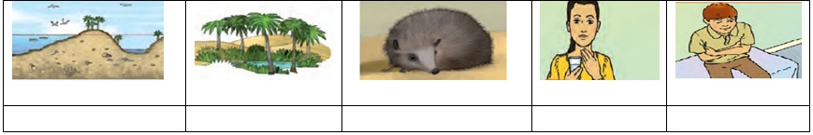
2- Listen and choose the correct answer :
1- When the sun goes down at ( sunrise – sunset – sunshine )
2- Jerboa and gazelle are ( water – sea – desert) animals .
3- Rania is hot . she has a ( fever – cold – sore throat )
________________________________________________________________________
( B ) Speaking
3- Complete the following dialogue :
( sick – Thank – wrong – medicine – earache – since )
Doctor : What’s _______ with you , Omar ?
Omar : I have an ____________ .
Doctor : How long have you been _______ ?
Omar : I’ve been sick ________ last night .
Doctor : Take this ____________ .
Omar : ____________ you .
_____________________________________________________________________
4- Match ( A) with ( B ) :
 | ( A ) |  | ( B )
1 | How many meters is the Dead Sea below sea level ? |  | I can use flippers
2 | What can you use to swim faster ? |  | It’s 400 meters .
3 | How long has Ben been tired ? |  | It comes from the sea and rivers
4 | Where does rain come from ? |  | He has been tired for a week
________________________________________________________________________
( C )– Reading
5- Read the passage then answer the following questions :-

Ben’s mum took the children to the doctor’s clinic . The children had colds . They should go home
And stay in bed until they feel better . Omar’s mum , Rania and Omar were also at the clinic .
Omar had flu and Rania had a sore throat . The doctor gave them some medicine .
Mr Ali had five children in his class the next morning . The other children were at home .
They were not feeling well . There is a flu bug going around .

- Read and answer : -
- What’s wrong with Ben and Amy ? _________________________________________ .
- How many children were in Mr Ali’s class ? ___________________________________ .
- What bugs are going around ? ____________________________________________
_________________________________________________________________________
- Read and put ( T) or ( F ) : -
1- The doctor gave the children some sweets . ( )
2- There were six children in Mr Ali’s class . ( )
3- Omar and Rania were sick too . ( )
__________________________________________________________________________
- Find in the passage :-
1- The opposite of : worse x ________ took x ________ hot x __________
2- The meaning of : good = _________ house = ________
3- Three illness : __________ , ___________ , ___________ .
4- A job : _____________ .
5- A number : _______________ .

- Words and Structure .
6-Choose the correct answer :-
1- I’ve been tired ( for – since – every ) a week .
2- Hassan hasn’t slept well ( for – since – until ) last night .
3-The sun ( make – makes – made ) the water hot .
4- She has ( ever – never – since ) traveled to Egypt .
5- Have you ever ( see – saw – seen ) a jerboa ?

7- Do as shown between brackets : -
1- Huda has been in this school for 2011 ( correct )
___________________________________ .
2- climbed – never – a mountain – Bilal – has . ( rearrange )
____________________________________
3- I’ve been tired for an hour . ( make a question )
____________________________________
4- hassan and rula have been to gaza ( write correctly )
____________________________________
5- flew – fallen – done – worn ( odd one out )
____________________________________

8- Read and think :-
1- It’s a beautiful place in the desert . It has palm trees and springs . It’s an __________

Good luck ^_^

