State of Palestine Grade : Nine
Ministry of Education & Higher Education English Final Exam Directorate of Education/ Jenin Date : /12/2014
Al Hashimiya Secondary Girls School Total Mark : 60 p
Time : 9.m Name:……………..
===================================================================================================== Part One : Reading ( 20 pts )
Read the following text then answer the questions that follow :

Some of the world’s oldest cities were built in Palestine, and they were constructed with excellent
stone. This building stone and also marble were cut by our ancestors from the Holy Land itself.
Today, the stone industry remains very important: with its beautiful colours and excellent quality,
Palestinian stone is often preferred by architects round the world.
Stone was not always produced as efficiently as it is now. In ancient times, it was very difficult to
cut stone. Everything was done by hand, and it was slow, hard work. Now, however, technology
has come to the rescue, and finished stone is produced very efficiently.
Over 60% (sixty per cent) of the 262 quarries are near Hebron and Bethlehem. The stone is then
cut and finished by 15,000 workers in 618 factories, and many of these are also in the same area.
However, quarries are found in other places, too, and there are factories everywhere. Together,
they produce 4.5% (four point five per cent) of the world’s building stone. They also make 450
million dollars a year for Palestine, and they provide over 22,000 jobs.
The world stone industry is growing at 9% a year. And with our natural advantages, we can raise
Palestinian production even faster. But to do this, we need to learn more about different needs
round the world. The industry is therefore studying world markets carefully. If it can continue to
grow, it will bring Palestine a lot more jobs and money.
Questions :
( A ) Read and mark the sentences true ( ✔ ) or false(✘).
1-Technology has made stone production a little more efficient than it used to be . ( )
2- The Hebron and Bethlehem areas are the biggest centres of stone production. ( )
( B ) Answer the following questions :
1- Where did our ancestors cut stone marble ?
……………………………………………………………………………………..
2- How does the stone industry remain very important ?
……………………………………………………………………………………..
3- Why was it difficult to cut stone in the past ?
……………………………………………………………………………………..
4- What made finished stone more efficiently ?
……………………………………………………………………………………..
5- How can we raise Palestinian production even faster ?
……………………………………………………………………………………..
6- What will happen if industry study world markets carefully ?
……………………………………………………………………………………………………
( C ) Say what do the underlined words refer to :
1- The pronoun they ( line 1 )………………… 2- The pronoun itself ( line 2 ) ……………………
3- The pronoun it ( line 5 ) …………………… 4- The pronoun these ( line 9 ) ……………………
( D ) Find words from the text that means the same as :
1- new : ……………….. 2- damaged : ……………………
( page 1 )
( E ) Find words from the text that almost mean the opposites :
1- children : ………………. 2- lost : ……………………
( F ) Complete the following statements :
1- Over 60% (sixty per cent) of the 262 quarries are near ………………………………………
2- They also make …………. million dollars a year for Palestine, and they provide over ……………… jobs.
3-………………………… is therefore studying world markets carefully .
==================================================================================
Part Two : Vocabulary : ( 20pts )
( A ) Choose one word from the box to complete the following sentences :
Collection – continent – reach – jewelry– ruler
1- Khalid loves all things. He has a …………… of stamps and coins.
2- I have to ………….. the airport by 4:30. I don’t have enough time.
3- There are six …………. in the world. The biggest is Asia.
4- Roman women used to wear beautiful ……………….
5- The Sultan is the …………. Ottoman Empire.
======================================================================
( B ) Match the words to its meaning:
1 | king | a- ( ) | win a fight
2 | defeat | b- ( ) | generous
3 | only | c- ( ) | ruler
4 | take over | d- ( ) | control
5 | intelligent | e- ( ) | just
======================================================================
( C ) Choose one word from the box to write it beside its opposite :
Take out - inside - exciting - ancient - forget
1-modern : ……………………. 2- boring : …………………. 3- outside : ………………….
4- put away : ………………….. 5- remember : ……………………
======================================================================
( D ) Odd one out.
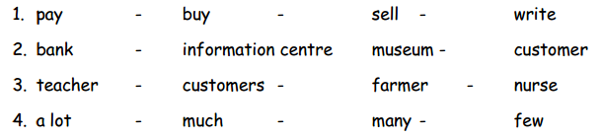

( page 2 )

Part Three : Language : ( 20 pts )
( A ) Correct the verbs between brackets :
1- Ahmed is a cleaver engineer. He ……………. (live) in Rafah .
2- The bus ……………. (leave) from Gaza at 9:00 .
3- I have already………………. ( see ) a nice wardrobe.
4- While Samya was cleaning the dishes , she …………… ( break ) five of them .
5- My mother has been……………….. ( drive ) for three hours.
=======================================================================
( B ) Choose the correct answer :

1. It was a big party (a few – not many – a lot ) of people came .
2. I can't buy this book I don’t have (a lot –much –many ) money , only 3 dollars .
3. I need just (a lot – few – a little ) sugar in my tea .
4. Only ( a few – a lot – many ) students passed the exam , it was really difficult.
5. It is too hot outside ,let's order (lots of – a lots of – lot of ) ice cream .
=======================================================================
(C ) Do as shown :
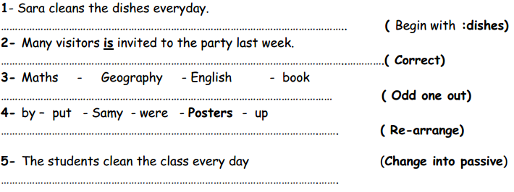
======================================================================
( D ) Circle the correct answer. (5 pts)
- He’s usually the ………………. Boy in the team.
a. fitter b. fit c. fittest d. fat
- I’m much ……..than I was. (good)
a. good b. gooder c. best d. better
- You should take things …………………. (slowly)
a. most slowly b. more slow c. more slowly d. slower

( page 3 )
- Don’t push yourself ………….. hard.
a. most b. enough c. too d. as
- I am not fit …………… to tarin.
a. as b. enough c. too d. more
======================================================================
Part Four : Writing ( 20 pts. )
( A ) Re-arrange the following : ( 8 pts )
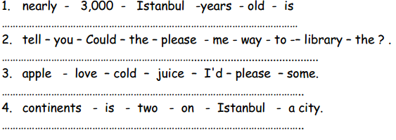
======================================================================
(B ) Re-arrange the following to make a meaningful dialogue : ( 12 pts. )
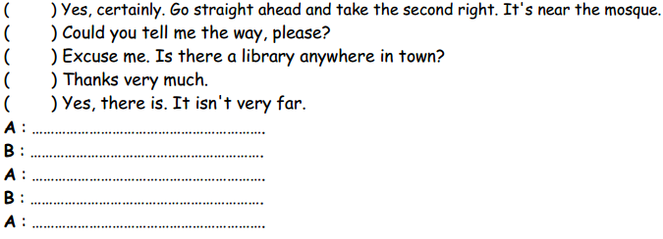

Good luck
Teacher : Rula Sha’ban

