Name: Grade: Date:

- Choice the right answer.

a- 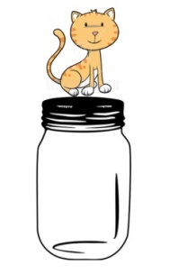 b- 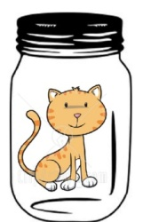 c- 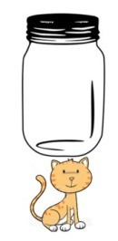

- The cat is under the jar.
- The cat is in the jar.
- The cat is on the jar.

- Write.
- It's _______ car. (Osama's mother)
His
- It's ________ Bicycle. (grandfather)
- It's ________ home. (Amjad and Hanan)
Her
- It's ________ pen. (Tariq)
- It's ________ computer. (Mahdi and Bilal)
Their
- It's ________ doll. (Faiza)
- It's ________ window. (Akram's family)

- Tick (√) or (X)
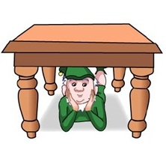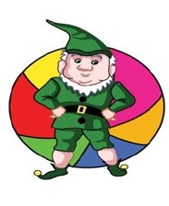
- The man is under the table. b- The man is in next to ball.

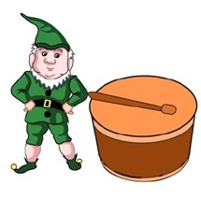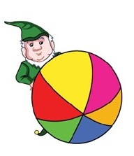
C- The man is on the drum. D- The man is behind the ball.

- Write
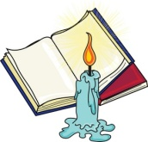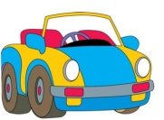
Is this your book ? _____________________
Bed
Jacket
Car
_______________________ No , it's not.
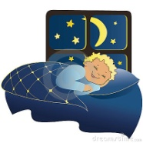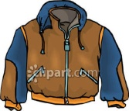

________________________ ______________________
Yes , it is. ______________________
Teacher: Tha'er Taha Head Teacher: Aziz

