  مديرية التربية والتعليم – خان يونس | امتحان لطلاب الصف الرابع للفصل الأول 2015 | Ministry of Ed-& Higher Education  Directorate of Education -KhanYounis  Date: / / 2015  مجموع الدرجات 30 درجة– الزمن : ********
ملاحظة: يجيب الطالب عن جميع أسئلة الامتحان اسم الطالب :----------------------- الشعبة :----------
I-Listening
Listen and circle: (3 marks) ضعي دائرة حول الكلمة التي تسمعيها
Bedroom kitchen bathroom garden | 1
Dancing drawing reading garden | 2
kilo bag box packet | 3

Fiona
Hello
Have
Are
From
Many
Complete the dialogue :- 6 marks)
HaLa: HeLLO ………………………..
Fiona:……………………..Hala
Hala :where ……………………….you from?
Fiona:Im……………………….. Jerusalem.
Hala :How……..brothers do you have?
Fiona :I………………..3brotherS.

اختر الاجابة الصحيحة : (2 marks) Choose the correct answer:
سالك المعلمWhat's your favorite hobby: ترد عليه قائلا: (ِA)
a-My favorite color is orange .
b-My favorite drink is lemonade.
c-My favorite hobby is swimming.

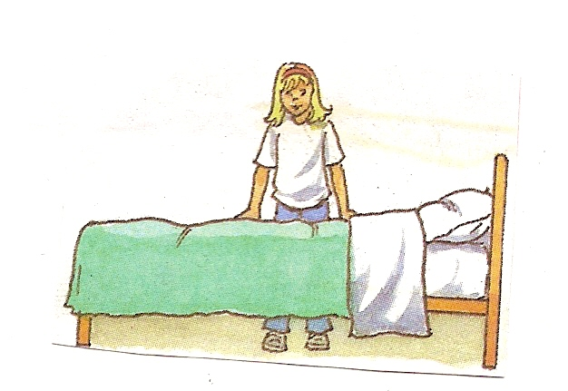
سالك المعلم ؟where's Fiona(B)
a-she's behind the bed .
b-she's in front of the bed.
c- she's in the bin .

READING
Read the paragraph and answer the following questions :-
MY brother is Ahmed .He is a doctor .He is from Gaza. His favorite hobby is reading.
Tick (T) or (f) :- (2 marks)
1-Ahmed is a doctor ( )
2- Ahmed is from Gaza ( )
Match the pictures with words : (3 marks)
Policeman
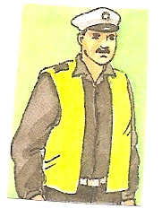
Farmer
Living room

Rearrange:
On-The –ball-is –table- the (1 mark)
…………………………………..........
Choose the correct answer: (3 marks)
1-Amals ………………………in the kitchen ( cook –cooking )
2-walid(his -her- their)class.
3- (Her –His ) name is Fiona .
Classify (6 marks)
green - swimming – playing – reading
blue - yellow
– blue -
Hobbies هوايات | # | Colorsــ الوان | #
 | 1 |  | 1
 | 2 |  | 2
 | 3 |  | 3
COPY: (4 marks)
The bin is in front of desk
________________________________________________________________________________________________________________________________________________________________________________________________________________________________________________________________________________________

